###### EX.NO:1

**AIM:**

To write a C program to perform branching and iterative constructs.

**ALGORITHMS :**

1. **RESULT CALCULATION : PASS / FAIL**

Step 1 : START

Step 2 : DECLARE m1, m2, m3, m4, m5, per Step 3 : GET m1, m2, m3, m4, m5

Step 4 : IF m1 >= 35 AND m2>=35 AND m3>=35 AND m4>=35 AND m5>=5 PRINT “PASS"

Step 5 : ELSE

PRINT “FAIL”

Step 6 : COMPUTE per = (m1 + m2 + m3 + m4 + m5) / 5 Step 7 : PRINT percentage per

Step 8 : STOP

###### FIND THE GREATEST OF THREE NUMBERS

Step 1 : START

Start 2 : GET A, B, C

Start 3 : LET max = A

Start 4 : IF B > max THEN max =B Start 5 : IF C>max THEN max=C Start 6 : PRINT (“%d is

large”,max)

Start 7 : STOP

###### FIND THE GIVEN NUMBER IS POSITIVE, NEGATIVE OR ZERO

Step 1 : Start. Start 2 : GET num

Start 3 : IF(num>0)

PRINT(“positive”)

Start 4 :ELSEIF (num<0) PRINT(“Negative”)

Start 5 : ELSE

PRINT(“zero”) Start 6 : STOP

###### IDENTIFY THE GIVEN CHARACTER IS ALPHABET OR DIGIT OR SPECIAL CHARACTER.

Step 1 : START

Step 2 : INPUT char

Step 3 : IF((c >= 'a' && c <= 'z')||(c >= 'A' && c <= 'Z'))

PRINT(“Alphabet”)

Step 4 : ELSE IF(c >= '0' && c <= '9') PRINT(“Digit”)

Step 5 : ELSE

PRINT(“special char”) Step 6 : STOP

###### REVERSE THE GIVEN NUMBER

Step 1 : START

Step 2 : INPUT n

Step 3 : INITIALIZE rev = 0 Step 4 : LOOP WHILE n>0

Step 5 : COMPUTE rev = rev * 10 + (n % 10) Step 6 : COMPUTE n /= 10

Step 7 : END WHILE

Step 8 : PRINT rev Step 9 : STOP

###### PRINT THE FIRST DIGIT OF A GIVEN NUMBER

Step 1 : START

Step 2 : GET num

Step 3 : WHILE n >= 10 Step 4 : COMPUTE n /= 10 Step 5 : END WHILE

Step 6 : PRINT (“The first digit is %d”, n) Step 7 : STOP

###### CHECK IF THE NUMBER IS PERFECT OR NOT.

Step 1 : START

Step 2 : DECLARE n, sum = 0 Step 3 : GET n

Step 4 : FOR(INT i=1; i<n; i++) DO

Step 5 : IF n%i == 0 THEN sum += i Step 6 : END FOR

Step 7 : IF n == sum THEN

PRINT (“Perfect Number”)

Step 8 : ELSE PRINT (“Not a Perfect Number”) Step 9 : STOP

###### PRINT THE PATTERN

Step 1 : START

Step 2 : DECLARE n

Step 3 : GET n

Step 4 : FOR (INT i = 1; i <= n; i++) DO

Step 5 : FOR(INT j = 1; j <= i; j++) DO PRINT (“*”) Step 6 : END FOR

Step 7 : PRINT(“\n”) Step 8 : END FOR Step 9 : STOP

**PROGRAMS :**

* 1. **RESULT CALCULATION : PASS / FAIL**

#include<stdio.h> int main()

{

int sub1, sub2,sub3,sub4,sub5; int total;

float percentage;

printf("Enter the five subject Marks:");

scanf("%d %d %d %d %d",&sub1,&sub2,&sub3,&sub4,&sub5); if(sub1>50 && sub2>50 && sub3>50 && sub4>50 && sub5>50)

{

total=sub1+sub2+sub3+sub4+sub5; percentage=total*100 / 500;

printf("Passed with %.2f percentage",percentage);

}

else

printf("Result is Fail"); return 0;

}

**OUTPUT :**



* 1. **FIND THE GREATEST OF THREE NUMBERS**

#include <stdio.h> int main()

{

int a,b,c; int largest;

printf("Enter the value of a b and c:"); scanf("%d %d %d",&a,&b,&c); if(a>b && a>c)

printf(“A is the largest number”); else if(b>a && b>c)

}

**OUTPUT :**

printf(“B is the largest number”); else

printf("C is the largest number”); return 0;



###### FIND THE GIVEN NUMBER IS POSITIVE, NEGATIVE OR ZERO

#include <stdio.h> int main()

{

int num; char choice;

printf("Enter an integer number :"); scanf("%d",&num);

if(num==0)

printf("Number is ZERO."); else if(num>0)

printf("Number is POSITIVE."); else

printf("Number is NEGATIVE."); return 0;

}

**OUTPUT :**



* 1. **IDENTIFY THE GIVEN CHARACTER IS ALPHABET OR DIGIT OR SPECIAL CHARACTER.**

#include <stdio.h> int main()

{

char ch;

printf("Enter any character: "); scanf("%c", &ch);

if((ch >= 'a' && ch <= 'z') || (ch >= 'A' && ch <= 'Z')) printf("'%c' is alphabet.", ch);

else if(ch >= '0' && ch <= '9') printf("'%c' is digit.", ch);

else

printf("'%c' is special character.", ch); return 0;

}

**OUTPUT :**



* 1. **REVERSE THE GIVEN NUMBER**

#include<stdio.h> int main()

{

int n, remind; int rev = 0;

printf("Enter a number :"); scanf("%d",&n);

while (n != 0)

{

remind = n % 10;

rev = rev * 10 + remind; n /= 10;

}

printf("\nThe Reversed Digit is %d",rev); return 0;

}

**OUTPUT :**



* 1. **PRINT THE FIRST DIGIT OF A GIVEN NUMBER.**

#include<stdio.h> int main()

{

int n;

printf("Enter an integer: "); scanf("%d",&n);

while (n >= 10) n /= 10;

printf("The first digit of the given input is %d",n); return 0;

}

**OUTPUT :**



* 1. **CHECK IF THE NUMBER IS PERFECT OR NOT.**

#include<stdio.h> int main()

{

int n;

int sum = 0;

printf("Enter an integer:"); scanf("%d",&n);

for(int i=1; i<n; i++)

{

if (n % i == 0) sum += i;

}

if (n == sum)

printf("The given number %d is a perfect number.",n); else

printf("The given number %d is not a perfect number.",n); return 0;

}

**OUTPUT :**



* 1. **PRINT THE PATTERN.**

#include<stdio.h> int main()

{

int n;

printf("Enter the count :"); scanf("%d",&n);

for(int i = 1; i <= n; i++)

{

for(int j = 1; j <= i; j++) printf("*");

printf("\n");

}

return 0;

}

**OUTPUT :**

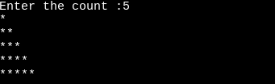

**RESULT :**

Thus, the C program to perform branching and iterative constructs was executed and the output was verified successfully.



**AIM**

To write a C program to perform functions.

**ALGORITHMS**

1. **IDENTIFY THE GIVEN INPUT IS EITHER POSITIVE NEGATIVE OR ZERO USING FUNCTIONS**

Step 1 : Start

Step 2 : Prompt the user to enter a number. Step 3 : Store the user entered value in a.

Step 4 : Declare and define a function num which takes single parameter of input number Step 5: Call num function

Step 6: Construct an if else statement.

Step 7 : If the if part (a>0) is true ,then print the number is positive.

Step 8 : If the else if part (a<0) is true ,then print the number is negative. Step 9 : If the else part is true, then print the number is zero

Step 10: End

###### CHECK A GIVEN NUMBER IS A PERFECT NUMBER OR NOT USING FUNCTIONS

Step 1: START

Step 2: INITIALIZE num, s Step 3: GET num

Step 4: CALL perfect(num)function

Step 5: IF s==num THEN PRINT “Perfect number” Step 6: ELSE PRINT “Not a Perfect number”

Step 7: STOP

perfect(n)

Step 1: INITIALIZE a=1, sum=0

Step 2: WHILE a<n Step 3: IF n%a==0

Step 4: COMPUTE sum=sum+a Step 5: COMPUTE a++

Step 6: RETURN sum

###### PROGRAM TO ACCEPT AN INTEGER AND RETURN THE NUMBER OF FACTORS USING FUNCTIONS

Step 1: Start

Step 2: Prompt the user to enter a number. Step 3: Store the user entered value in number.

Step 4: Declare and define a function find_factors Step 5: Call find_factors function

Step 6: Construct a for loop for (i = 1; i <= Number; i++)

Step 7: Using if statement if the entered number is divisible by 0,then print the number. Step 8: Print the factors of the entered number.

Step 9: End

###### PROGRAM TO SUM OF ITS DIGIT UP TO A SINGLE VALUE USING RECURSION

Step 1: Start

Step 2: Read a input number

Step 3: Declare and define a function which takes single parameter of input number Step 4: Call sum(value) function

Step 5: Print the value of total Step 5: Stop sum(n)

Step 1: If n not equal to 0, then call the function by summing the least digit using modulo operator

Step 2: Set the condition where if total>9 and number !=0, if it is true then convert total value into ‘n’ and call the function again as a recursive one.

Step 3: Return the total value

###### PROGRAM TO CONVERT DECIMAL NUMBER TO BINARY NUMBER USING RECURSION

Step 1: Start

Step 2: Get input from the user(decimal number)

Step 3: Declare and define a function [convert(int dec)] which takes a single parameter of input number. Step 4: Call convert(dec)function

Step 5: Print the binary equivalent convert (dec)

Step 1: Decide the input decimal number by 2 and store the remainder

Step 2: Store the quotient back to the input number variable Step 3: Repeat the process till quotient becomes zero

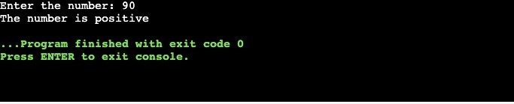

**PROGRAMS**

* 1. **IDENTIFY THE GIVEN INPUT IS EITHER POSITIVE NEGATIVE OR ZERO USING FUNCTIONS**

#include<stdio.h> void num(int a); void main()

{

int a;

printf("Enter the number: "); scanf("%d",&a);

num(a);

}

void num(int a)

{

if(a>0)

{

printf("The number is positive");

}

else if(a<0)

{

printf("The number is negative");

}

else

{

printf("The number is zero");

}

}

**OUTPUT:**

## 11

###### CHECK A GIVEN NUMBER IS A PERFECT NUMBER OR NOT USING FUNCTIONS

#include <stdio.h> int main()

{

int i, num, sum = 0; printf("Enter a number: "); scanf("%d", &num);

for(i = 1; i <= num / 2; i++)

{

if(num%i == 0)

{

sum=sum+ i;

}

}

if(sum == num && num > 0)

{

printf("%d is a \" PERFECT NUMBER\"", num);

}

else

{

printf("%d is \"NOT PERFECT NUMBER\"", num);

}

return 0;

}

#include <stdio.h> int main()

{

int i, num, sum = 0; printf("Enter a number: "); scanf("%d", &num);

for(i = 1; i <= num / 2; i++)

{

if(num%i == 0)

{

sum=sum+ i;

}

}

if(sum == num && num > 0)

{

printf("%d is a \" PERFECT NUMBER\"", num);

}

else

{

printf("%d is \"NOT PERFECT NUMBER\"", num);

}

return 0;

}

###### OUTPUT:

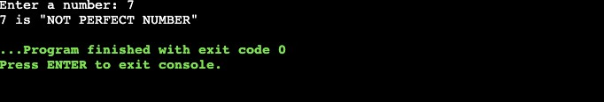

* 1. **PROGRAM TO ACCEPT AN INTEGER AND RETURN THE NUMBER OF FACTORS USING FUNCTIONS**

#include <stdio.h> void Find_Factors(int); int main()

{

int Number;

printf("\nPlease Enter number to Find Factors\n"); scanf("%d", &Number);

printf("\nFactors of a Number are:\n"); Find_Factors(Number);

return 0;

}

void Find_Factors(int Number)

{

int i;

for (i = 1; i <= Number; i++)

{

if(Number%i == 0)

{

printf("%d ", i);

}

}

}

###### OUTPUT:

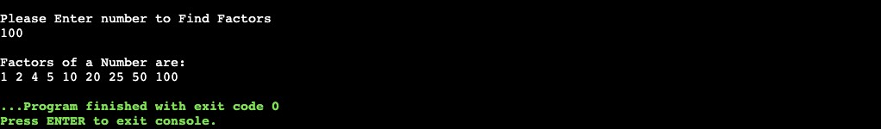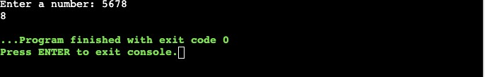

* 1. **PROGRAM TO SUM OF ITS DIGIT UP TO A SINGLE VALUE USING RECURSION**

#include<stdio.h> int main()

{

long int num;

int sum = 0, rem; printf("Enter a number: "); scanf("%ld", &num); while(num / 10 != 0)

{

sum = 0;

while(num != 0)

{

rem = num % 10; sum += rem; num = num / 10;

}

num = sum;

}

printf("%d", sum); return 0;

}

###### OUTPUT:

* 1. **PROGRAM TO CONVERT DECIMAL NUMBER TO BINARY NUMBER USING RECURSION**

#include<stdio.h> int binary_rec(int); int binary(int);

int main()

{

int num;

printf("Enter a Decimal number:"); scanf("%d", &num);

printf("Binary Equivalent (Iterative) of %d is %d\n", num, binary(num)); printf("Binary Equivalent (Recursive) of %d is %d\n", num, binary_rec(num)); return 0;

}

int binary_rec(int num)

{

if(num == 0)

return 0; else

return((num % 2) + 10 * binary_rec(num/2));

}

int binary(int num)

{

int rem, bin = 0, place = 1; while(num)

{

rem = num % 2; num = num / 2;

bin = bin + (rem * place); place = place * 10;

}

return(bin);

}

###### OUTPUT:

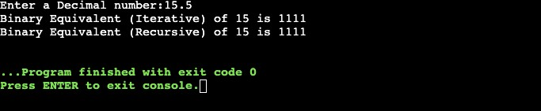

**RESULT:**

Thus the program has been executed and tested successfully.

|  |  |
| --- | --- |
| **EX.NO: 3** | **ARRAYS AND STRINGS** |
| **AIM:**  To write a C Program to perform operations on Arrays and Strings.  **ALGORITHMS:**   1. **PRINT THE SECOND LARGEST NUMBER IN AN ARRAY**   Step:1: Start  Step:2: Initialize arr[100], size, i, max1, max2 Step:3: Get size  Step:4: Iterate a ‘for’ loop using ‘i’ from 0th index to last index Step:5: Get arr[i]  Step:6: Set max1 = max2 = INT_MIN  Step:7: Iterate a ‘for’ loop using ‘i’ from 0th index to last index Step:8: If arr[i] > max1  Step:9: Set max2 = max1, max1 = arr[i] Step:10: Else If arr[i] > max2 && arr[i] < max1 Step:11: Set max2 = arr[i]  Step:12: Print max2 Step:13: Stop   1. **IDENTIFY MISSING NUMBER IN AN ARRAY**   Step:1: Start  Step:2: Read size for an array  Step 3: Declare supportive variables for loop  Step 4: Read runtime inputs for one dimensional array using a ‘for’ loop Step 5: While reading input through scanf, identify smallest and largest Step 6: Use, another loop for summing all the elements of an array  Step:7: Initialize the variable of t_sum and s_sum for getting answer for missing number | |

Step 8: Utilize the formula sum of ‘N’ numbers to produce the answer Step:9: Print the result of missing number

Step:10: Stop

###### REMOVE A PARTICULAR ELEMENT IN AN ARRAY

Step:1: Start

Step:2: Set index value as -1 initially. i.e. index = -1

Step:3: Get key value from the user which needs to be deleted.

Step:4: Search and store the index of a given key

[ index will be -1, if the given key is not present in the array] Step:5: If index not equal to -1then

Step:6: Shift all the elements from index + 1 by 1 position to the left. Step:7: Else then print "Element Not Found"

Step:8: Stop

###### PRINT THE LARGEST NUMBER IN EVERY COLUMN OF A MATRIX

Step:1: Start

Step:2: Initialize m, n, i, j, mat1[m][n] Step:3: Get m,n

Step:4: Iterate a ‘for’ loop using ‘i’ from 0th index to m Step:5: Iterate a ‘for’ loop using ‘j’ from 0th index to n Step:6: Get mat1[i][j]

Step:7: Call maxi_col(mat1,m,n) function Step:8: Stop

maxi_col(mat1,m,n) function:

Step:1: Initialize i, j

Step:2: Iterate a ‘for’ loop using ‘i’ from 0th index to n

Step:3: Declare max = mat[0][i]

Step:4: Iterate a ‘for’ loop using ‘j’ from 0th index to n Step:5: If mat[j][i] > max then

Step:6: Set max = mat[j][i] Step:7: End If

Step:8: Print max

###### CHECK THE EQUALITY OF TWO STRINGS WITHOUT USING PREDEFINED FUNCTIONS

Step 1: Start.

Step 2: Read size separately for two character array Step 3: Scan input in runtime for array1 and array2 Step 4: Declare supportive variable for a while loop ‘i'

Step 5: Set i value as 0, Check condition as array1 should not be ‘\0 and array2 should not be ‘\0’

Step 6: Within while loop, if array[i] !=array2[i] Then Increment the counter variable and break the loop

Step 7: End While

Step 8: If count ==0 , print “Both strings are same” Else print “Both strings are not same” Step 9: Stop

###### REMOVE UNWANTED WHITE SPACES IN A SENTENCE

Step:1: Start

Step:2: Initialize inputString[100], outputArray[100], readIndex = 0, writeIndex Step:3: Input inputstring

Step:4: Within while loop, if inputString[readIndex] == ' ' Then Increment the readIndex variable and break the loop

Step:5: Iterate a ‘for’ loop using ‘readIndex’ from 0th index to n

Step:6: if “inputString[readIndex]==' ' && inputString[readIndex-1]==' ' ” then Step:7: continue

Step:8: Set outputArray[writeIndex] = inputString[readIndex] Step:9: Compute writeIndex++

Step:10: Set outputArray[writeIndex] = '\0'

Step:11: Print outputArray Step:12: Stop

###### PRINT THE STRING WITHOUT VOWELS

Step:1: Start

Step:2: Initialize the variables str[100], i, j, len=0 Step:3: Accept the input str

Step:4: Iterate a ‘for’ loop using ‘i’ from 0th index to len Step:5:If

“str[i]=='a'||str[i]=='e'||str[i]=='i'||str[i]=='o'||str[i]=='u'||str[i]=='A'||str[i]=='E'||str[i]=='I'||str[i]=='O'||str[i]

=='U' ”

Step:6: Iterate a ‘for’ loop using ‘j’ from 0th index to len Step:7: Compute str[j]=str[j+1]

Step:8: Compute len--

Step:9: Terminate both for loop.Print the string without vowels. Step:10:Stop

**PROGRAMS:**

1. **PRINT THE SECOND LARGEST NUMBER IN AN ARRAY**

#include <stdio.h> #include <limits.h> int main()

{

int arr[100], size, i; int max1, max2;

printf("Enter size of the array: "); scanf("%d", &size);

printf("Enter elements in the array: "); for(i=0; i<size; i++)

{

scanf("%d", &arr[i]);

}

max1 = max2 = INT_MIN; for(i=0; i<size; i++)

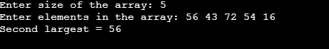

{

if(arr[i] > max1)

{

max2 = max1; max1 = arr[i];

}

else if(arr[i] > max2 && arr[i] < max1)

{

max2 = arr[i];

}

}

printf("Second largest = %d", max2);

return 0;

}

**OUTPUT:**

1. **IDENTIFY MISSING ELEMENT IN AN ARRAY**

#include <stdio.h> int main ()

{

int number[30];

int i, n,sum=0,small,big; printf("Enter the value of N:"); scanf("%d", &n);

printf("Enter the numbers:"); for (i = 0; i < n; ++i){

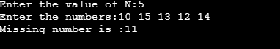

scanf("%d", &number[i]); if(i==0)

{

sum=sum+number[i]; small=number[i]; big=number[i]; continue;

}

if(number[i]<small) small=number[i];

if(number[i]>big)

big=number[i]; sum=sum+number[i];

}

int t_sum=(big*(big+1))/2;

int s_sum=((small-1)*(small))/2; int ans=t_sum - (s_sum+sum);

printf("Missing number is :%d",ans); return 0;

}

**OUTPUT:**

1. **REMOVE A PARTICULAR ELEMENT IN AN ARRAY**

#include<stdio.h> int main()

{

int key, i, index = -1,size;

int arr[size];

printf("Enter no of elements in an array:"); scanf("%d", &size);

printf("Enter elements in an array:"); for(i=0;i<size;i++)

{

scanf("%d", &arr[i]);

}

printf("Enter element to delete\n"); scanf("%d",&key);

for(i = 0; i < size; i++)

{

if(arr[i] == key)

{

index = i; break;

}

}

if(index != -1)

{

}

else

for(i = index; i < size - 1; i++) arr[i] = arr[i+1];

printf("New Array : "); for(i = 0; i < size - 1; i++)

printf("%d ",arr[i]);

printf("Element Not Found\n");

return 0;

}

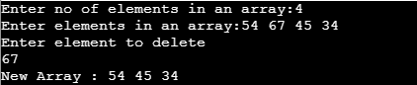

**OUTPUT:**

1. **PRINT THE LARGEST NUMBER IN EVERY COLUMN OF A MATRIX**

#include<stdio.h>

void maxi_col(int mat[][3], int m, int n)

{

printf("The largest number in every column:\n"); int i,j;

for(i = 0; i < n; i++)

{

int max = mat[0][i]; for(j = 1; j < m; j++)

{

if(mat[j][i] > max)

{

max = mat[j][i];

}

}

printf("%d\n",max);

}

}

int main()

{

int m, n;

printf("Enter row and column:"); scanf("%d %d",&m,&n);

int i, j;

int mat1[m][n]; printf("Enter elements:\n"); for(i = 0; i < m; i++)

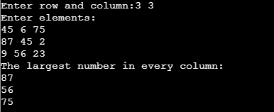

{

for(j = 0; j < n; j++) scanf("%d",&mat1[i][j]);

}

maxi_col(mat1,m,n); return 0;

}

**OUTPUT:**

1. **CHECK THE EQUALITY OF TWO STRINGS WITHOUT USING PREDEFINED FUNCTIONS**

#include<stdio.h> int main()

{

char str1[20], str2[20]; int i=0, c=0;

printf("Enter first string :"); gets(str1);

printf("Enter second string :"); gets(str2);

while((str1[i]!='\0') || (str2[i]!='\0'))

{

if(str1[i]!=str2[i]){ c++;

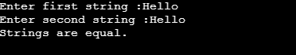

break;

} i++;

}

if(c==0)

printf("Strings are equal."); else

printf("Strings are not equal."); return 0;

}

**OUTPUT:**

1. **REMOVE UNWANTED WHITE SPACES IN A SENTENCE**

#include <stdio.h> #include <conio.h> #include <string.h>

int main(){

char inputString[100], outputArray[100]; int readIndex = 0, writeIndex; printf("Enter a String \n"); gets(inputString); while(inputString[readIndex] == ' '){

readIndex++;

}

for(writeIndex = 0;inputString[readIndex] != '\0'; readIndex++){ if(inputString[readIndex]==' ' && inputString[readIndex-1]==' '){

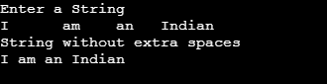

continue;

}

outputArray[writeIndex] = inputString[readIndex]; writeIndex++;

}

outputArray[writeIndex] = '\0';

printf("String without extra spaces\n%s", outputArray);

return 0;

}

**OUTPUT:**

1. **PRINT THE STRING WITHOUT VOWELS**

#include <stdio.h> #include <string.h> int main()

{

char str[100]; int i,j,len=0;

printf("Enter a string : "); gets(str);

len=strlen(str); for(i=0; i<len; i++)

{

if(str[i]=='a'||str[i]=='e'||str[i]=='i'||str[i]=='o'||str[i]=='u'||str[i]=='A'||str[i]=='E'||str[i]=='I'||str[i]=='O'||str[ i]=='U')

{



for(j=i; j<len; j++)

{

str[j]=str[j+1];

}

len--;

}

}

printf("After deleting the vowels, the string will be : %s",str);

return 0;

}

**OUTPUT:**

**RESULT:**

Thus, the program implementation using strings and arrays has been executed and tested successfully.

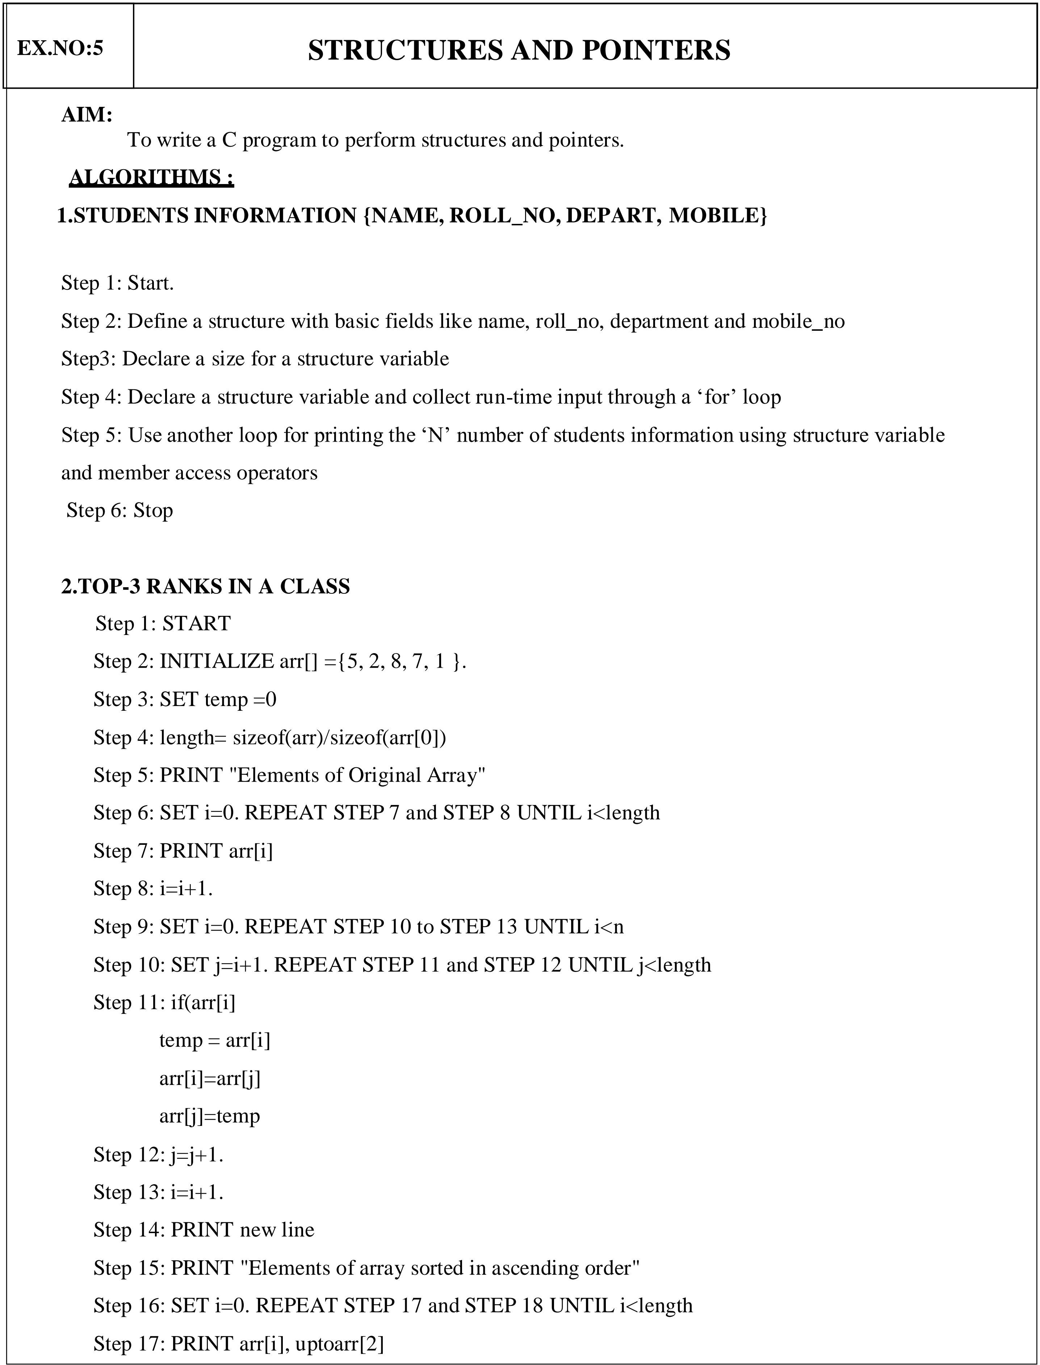 **4**

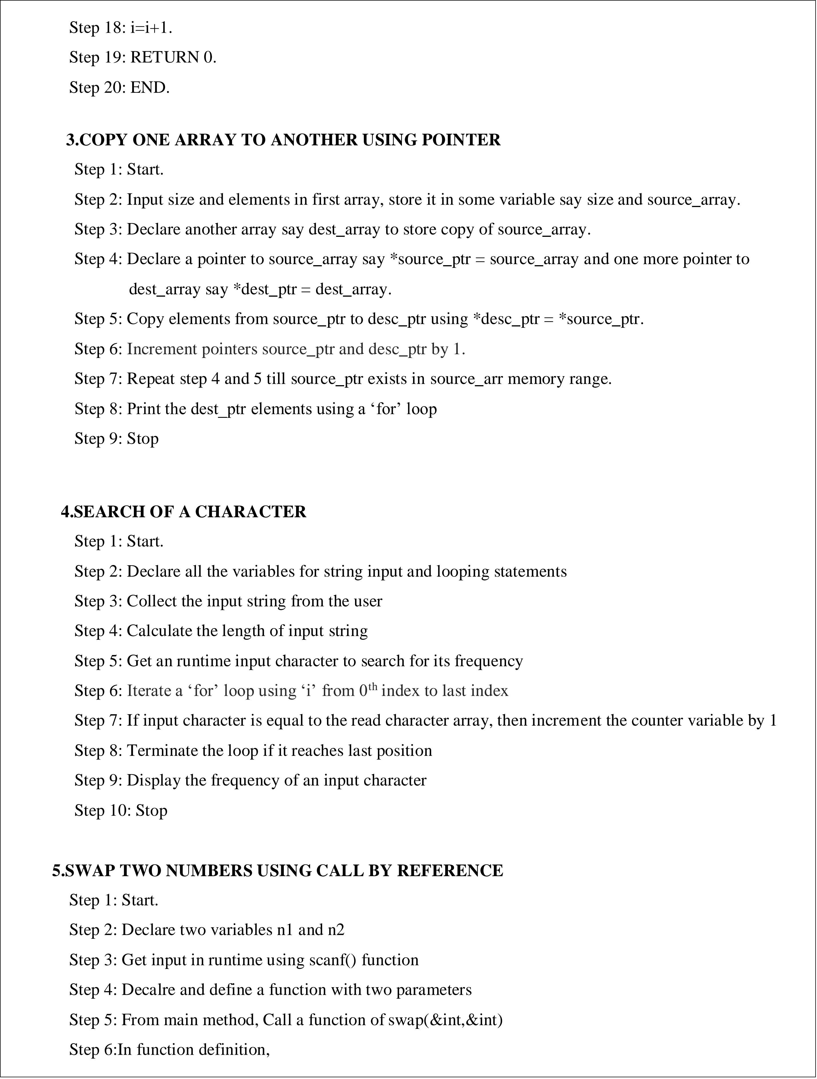

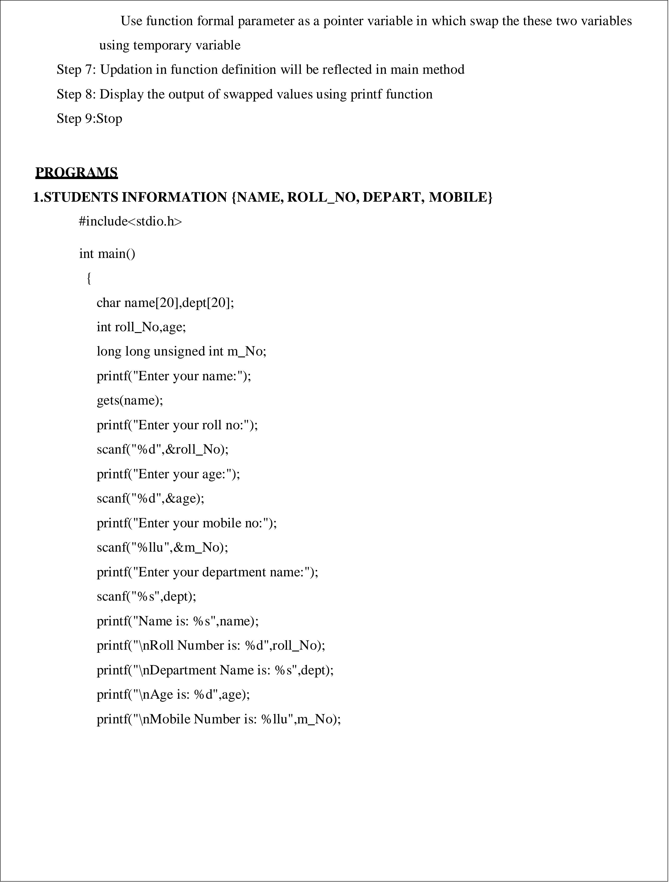

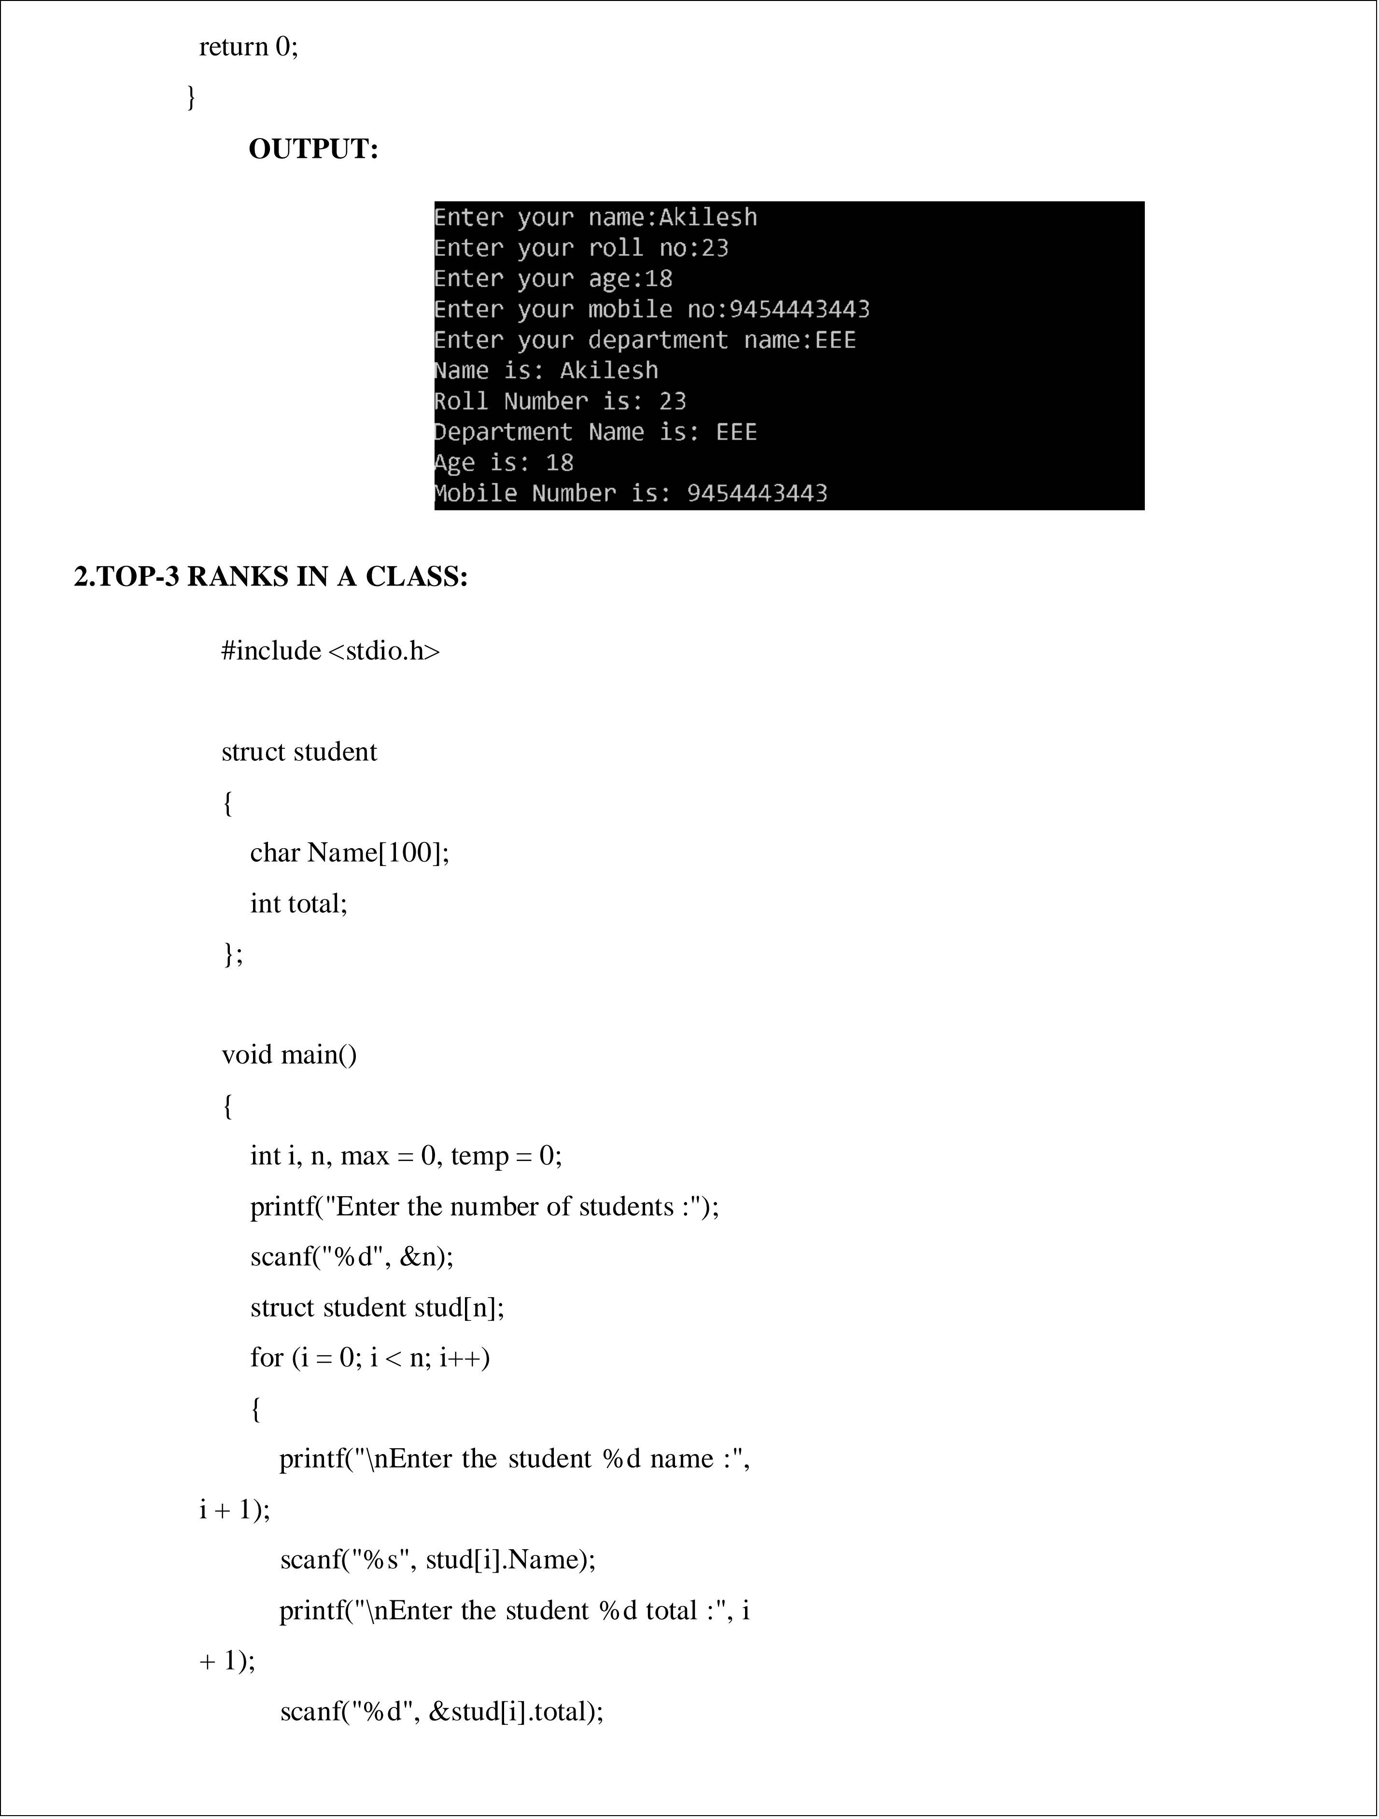

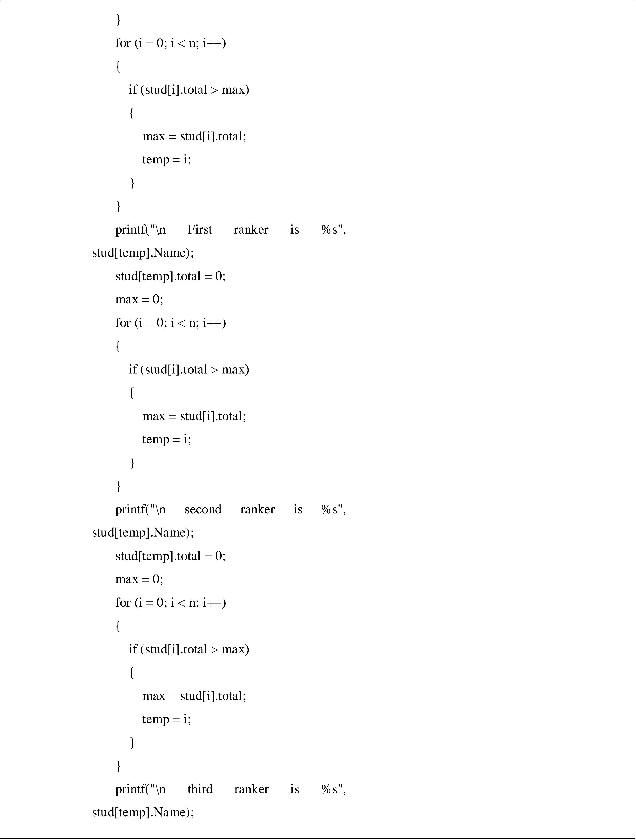

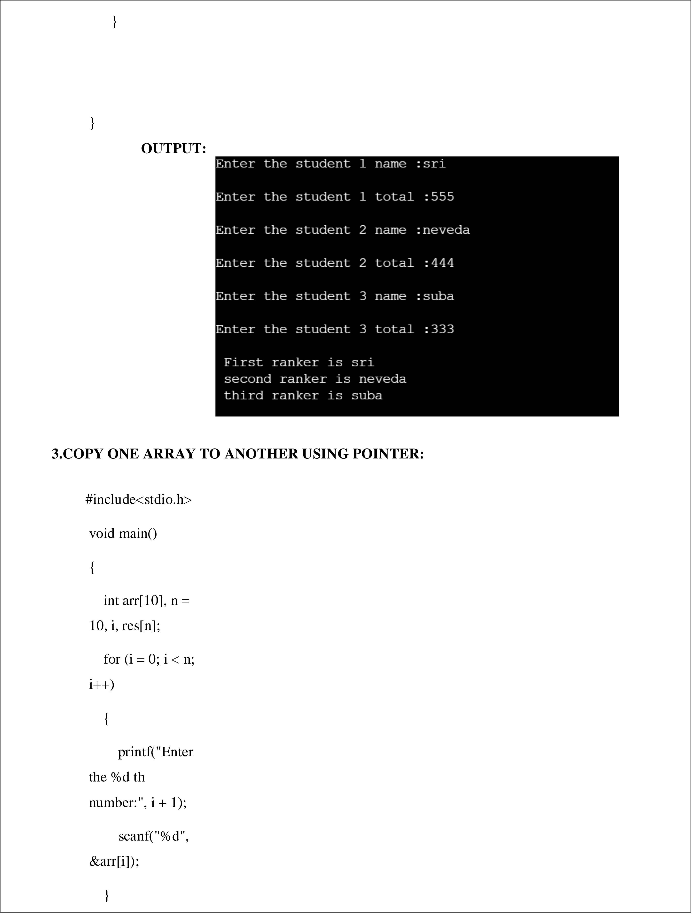

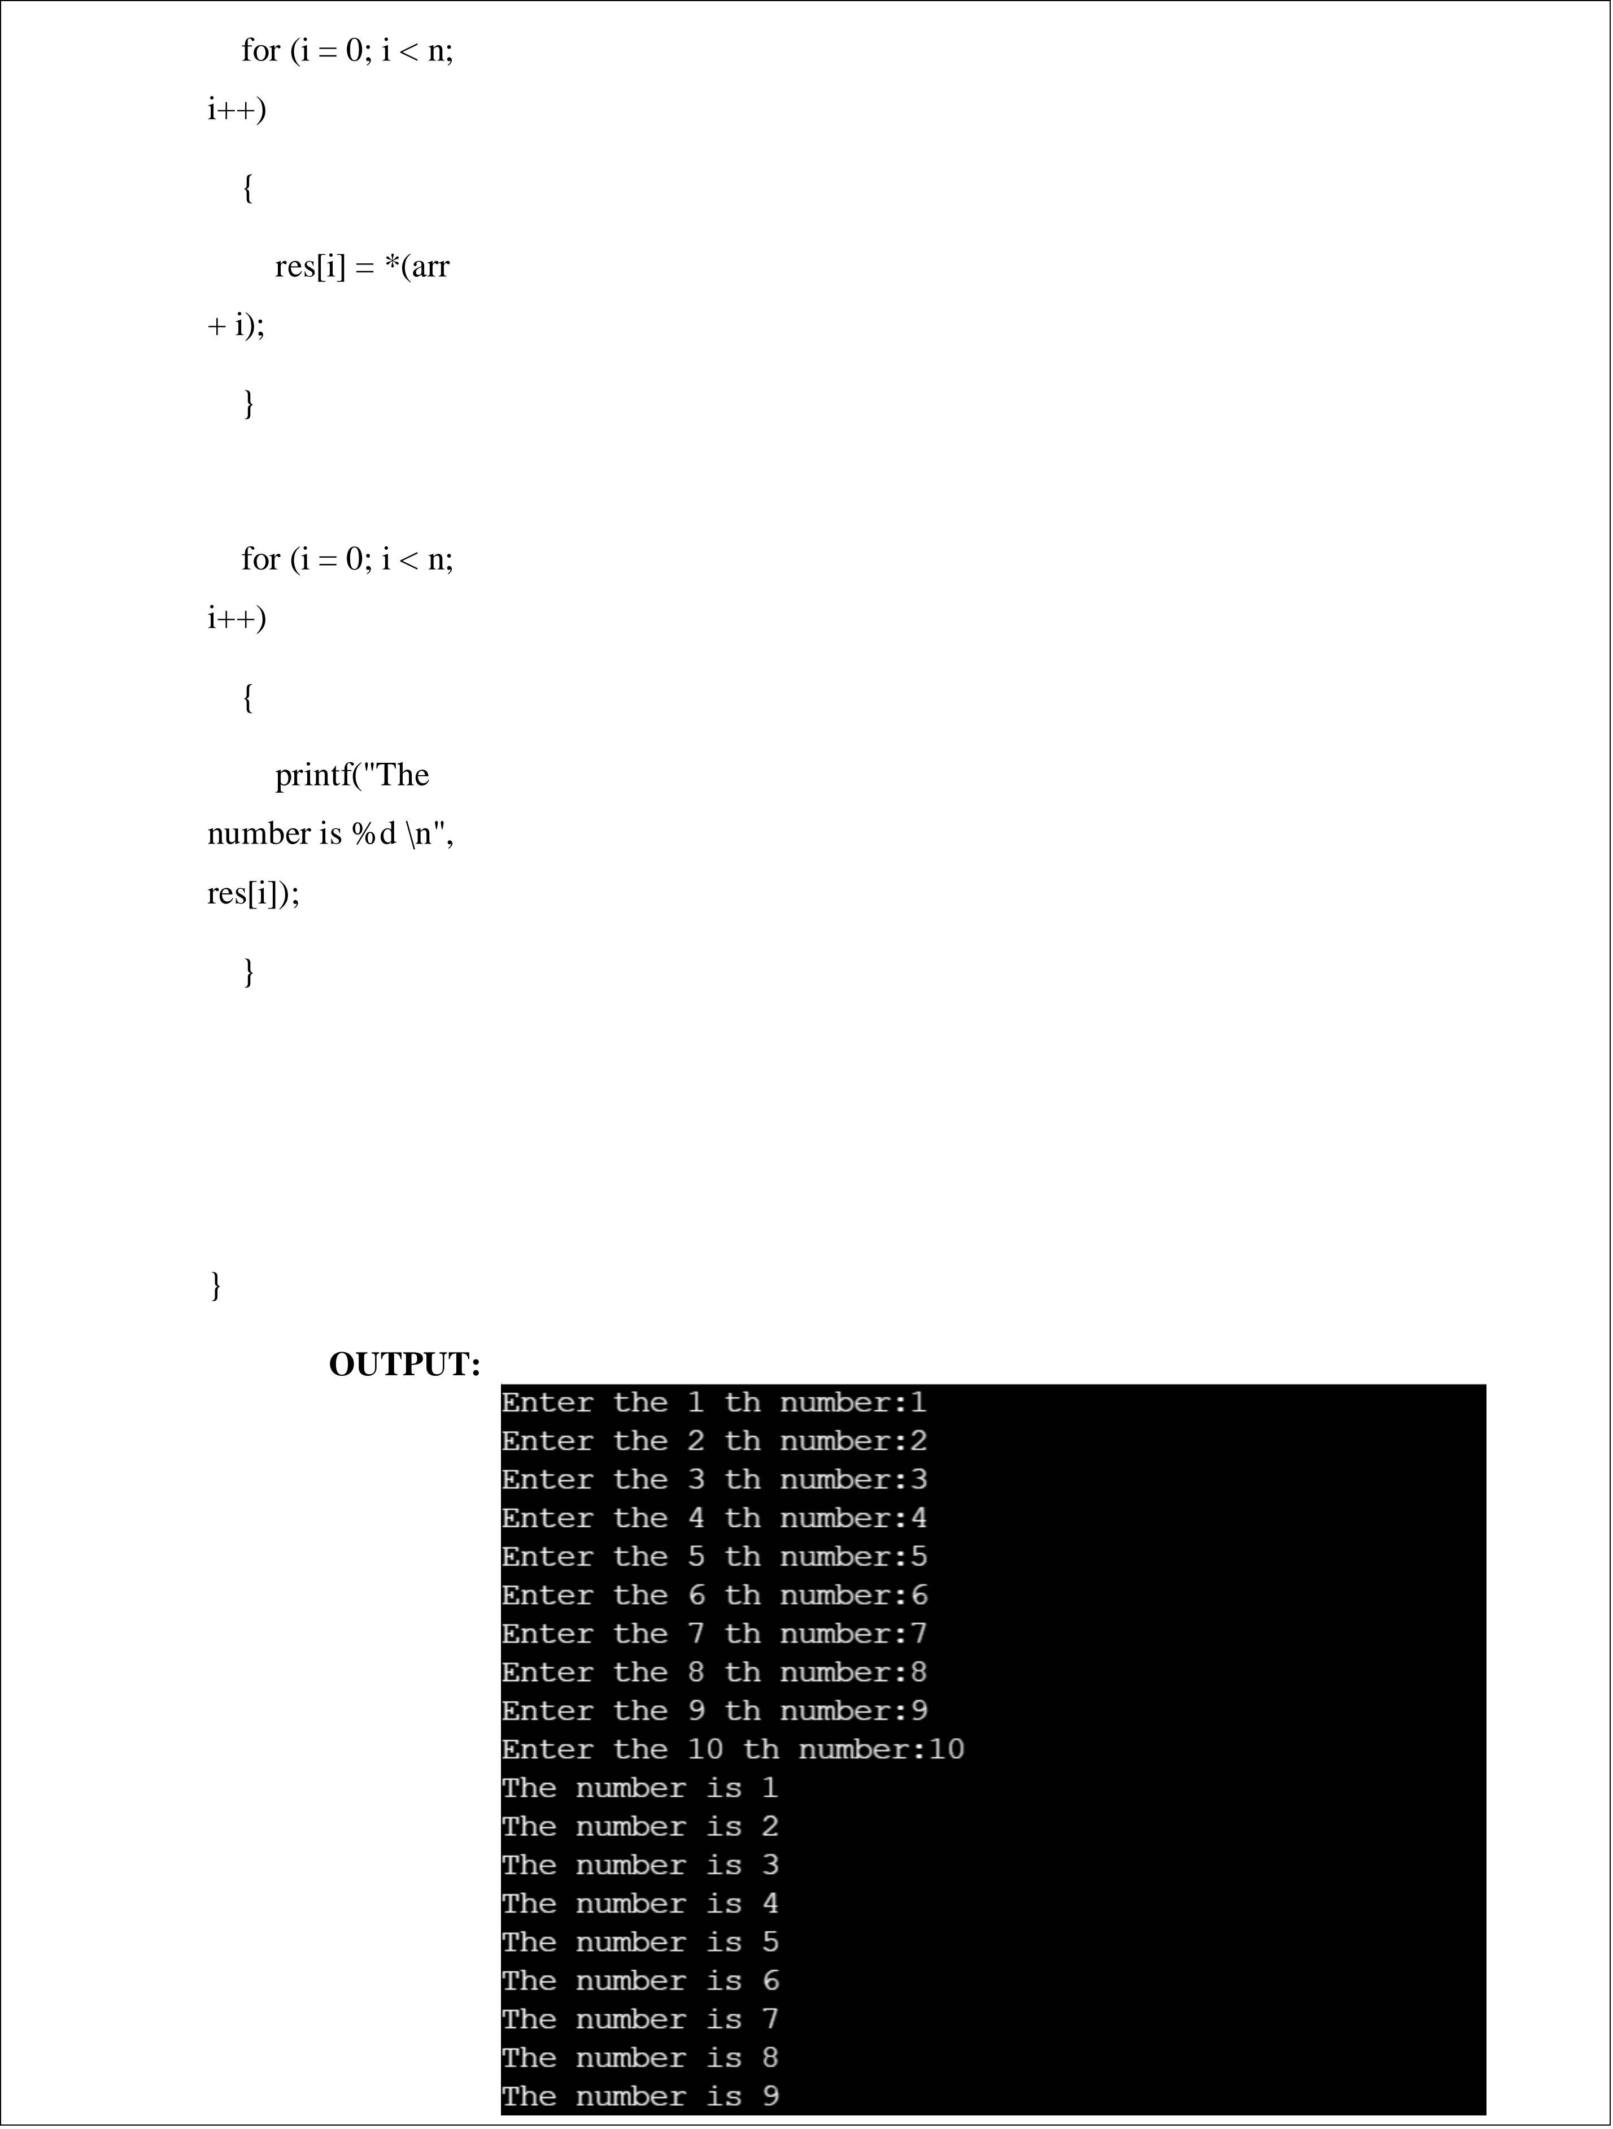

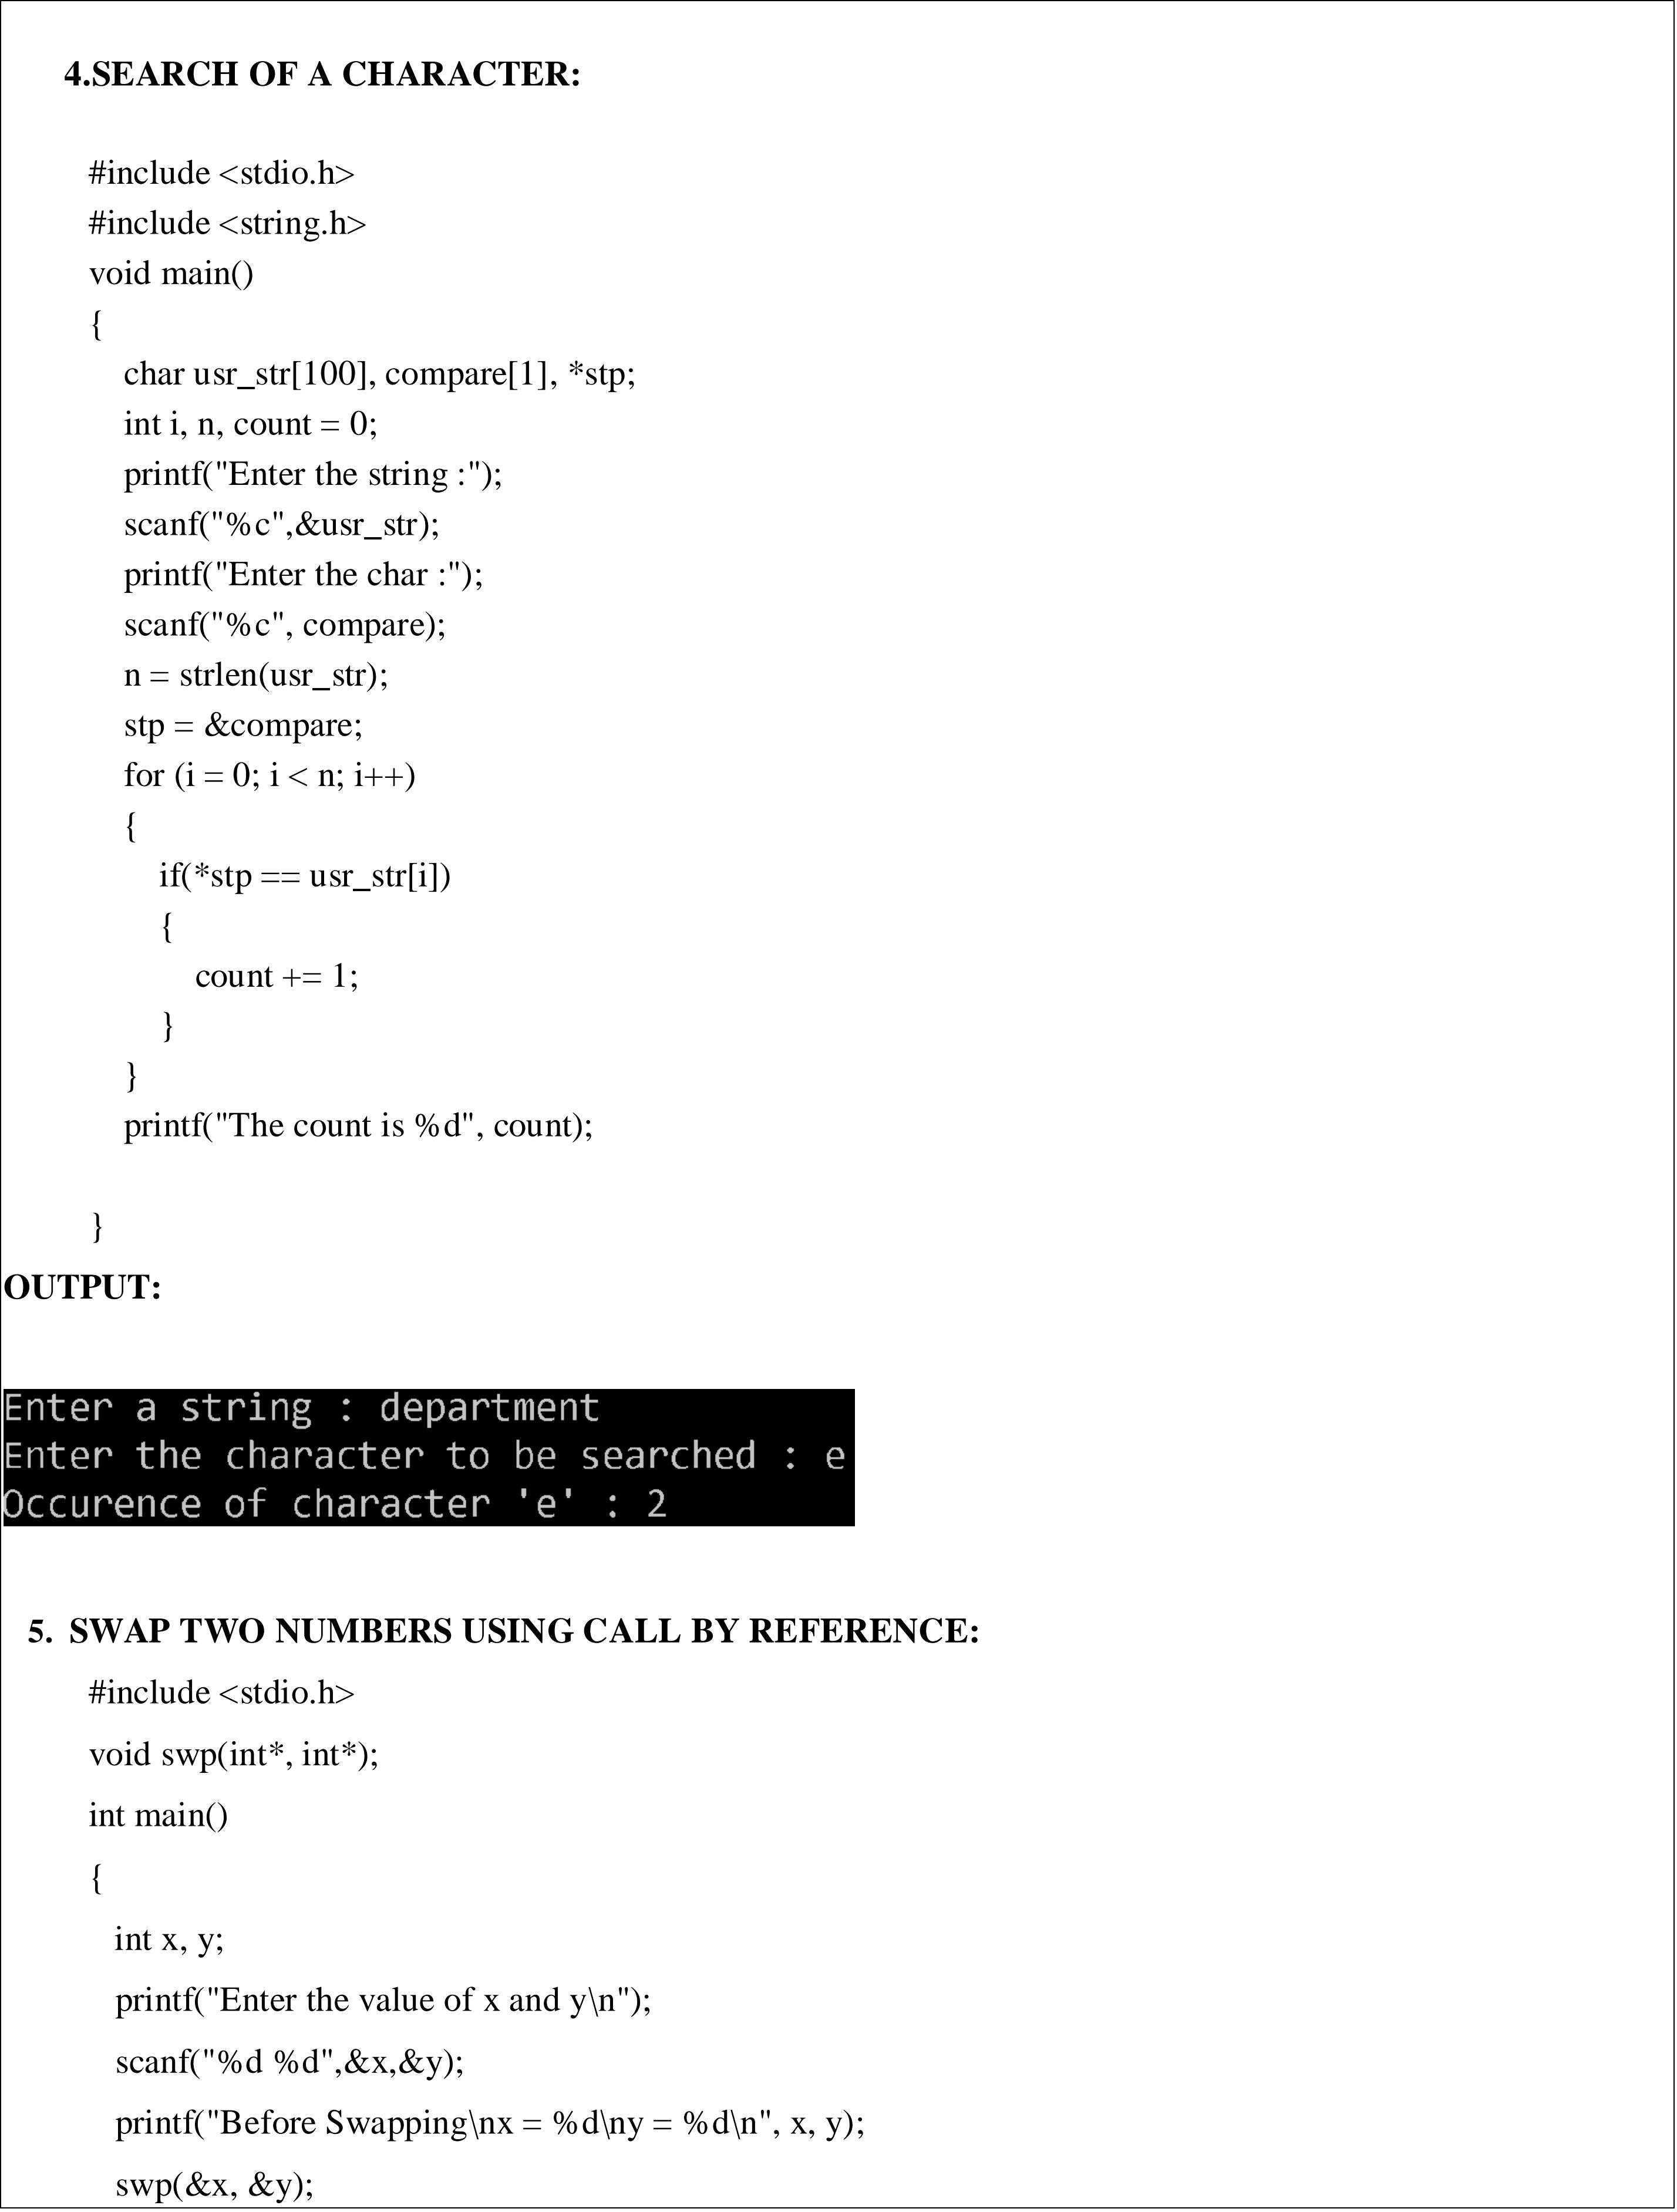

k.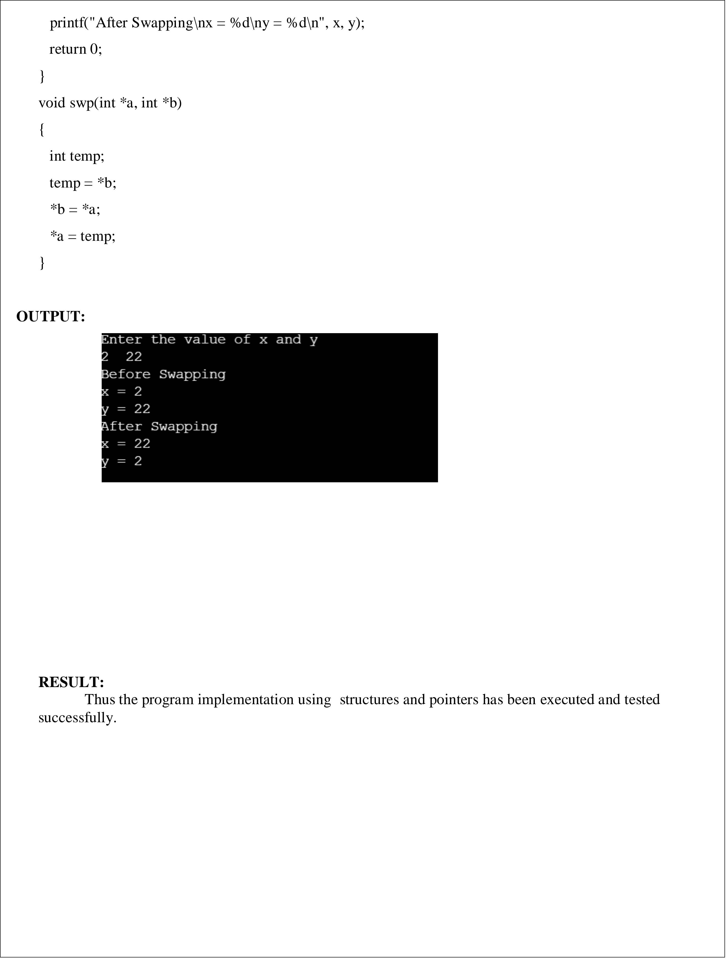

|  |  |
| --- | --- |
| **EX.NO:5** | **PROGRAMS USING FILES** |
| **AIM:**  To write a C program to perform operation using files  **ALGORITHMS**   1. **PROGRAM TO READ THE CONTENT OF A FILE AND DISPLAY**   Step 1:START  Step 2: OPEN a file using fopen() function and store its reference in a FILE pointer say fp.  Step 3:READ content from file using read option.  Step 4: CLOSE the file using fclose(fp) . Step 5:STOP   1. **PROGRAM TO COPY THE CONTENT OF ONE FILE TO ANOTHER FILE**   Step 1:START  Step 2:OPEN a file using fopen() with *fp1 in read mode  Step 3:OPEN a file using fopen() with *fp2 in write mode  Step 4:GET the content of the file using getc() Step 5:COPY the content of the file using putc() Step 6:The file is copied  Step 7:CLOSE both files using fclose(fp1),fclose(fp2)  Step 8:STOP   1. **PROGRAM TO CAPITALIZE FIRST LETTER OF EVERY WORD IN A FILE**   Step 1:START  Step 2:DECLARE ch,pre  Step 2:OPEN a file using fopen() with *fp in read mode  Step 3: OPEN a file using fopen() with *fp2 in write mode.  Step 4: GET the content of the file fp using getc()  Step 5**:** ch = pre - 32;  putc(ch, fp2);  boo = 0; to capitalize the first letter of every word | |

Step 6:STOP

###### 4. PROGRAM TO FIND THE NUMBER OF WORDS AND LINES IN A TEXT FILE

Step 1:START

Step 2:DECLARE count=1,lines=1

Step 3:OPEN a file using fopen() with fp* in read mode Step 4:GET the content of the file using getc()

Step 5**:** if(c ==' ' || c == '\n') Step 6 :INCREMENT ,count Step 7: if(c=='\n')

Step 8:INCREMENT, lines

Step 9:DISPLAY,count,lines Step 10:STOP

**PROGRAMS**

1. **PROGRAM TO READ THE CONTENT OF A FILE AND DISPLAY**

#include<stdio.h> int main()

{

FILE *fp; fp=fopen("C:/Users/dava/Desktop/s1.txt","r"); if(fp==NULL)

printf("file is not present"); else

printf("Opening the file\n"); fclose(fp);

return 0;

}

###### OUTPUT:

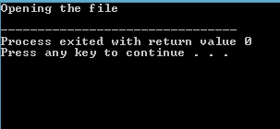

2 39

###### PROGRAM TO COPY THE CONTENT OF ONE FILE TO ANOTHER FILE

#include <stdio.h> int main()

{

FILE *fp1, *fp2; char ch;

fp1 = fopen("E:/c program/sample.txt","r"); fp2 = fopen("E:/c program/sample2.txt","w"); do {

ch = getc(fp1); putc(ch, fp2);

}while(ch != EOF); fclose(fp1); fclose(fp2);

printf("File copied successfully...");

}

###### OUTPUT:

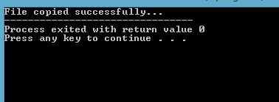

1. **PROGRAM TO CAPITALIZE FIRST LETTER OF EVERY WORD IN A FILE**

#include<stdio.h> #include<string.h>

int main()

{

FILE *fp, *fp2; char pre, ch;

int boo = 1;

fp = fopen("C:/Users/dava/Desktop/sample.txt", "r"); fp2 = fopen("C:/Users/dava/Desktop/sample1.txt", "w"); do

{

pre = getc(fp); if (!boo)

{

3 40

putc(pre, fp2);

}

if(boo)

{

ch = pre - 32; putc(ch, fp2); boo = 0;

}

if (pre == ' ')

{

boo = 1;

}

}while (pre != EOF); printf("Operation Successful"); fclose(fp);}

###### OUTPUT:

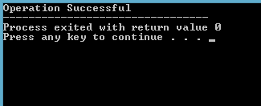

1. **PROGRAM TO FIND THE NUMBER OF WORDS AND LINES IN A TEXT FILE**

#include<stdio.h> int main()

{ char c; FILE *f;

int count = 1; int lines=1;

f = fopen("sample.txt","r"); do{

c=getc(f);

if(c ==' ' || c == '\n') count++;

4 41

if(c=='\n') lines++;

}while(c!=EOF);

printf("Number of words: %d\n", count); printf("Number of lines: %d",lines); fclose(f);

return 0;

}

###### OUTPUT:

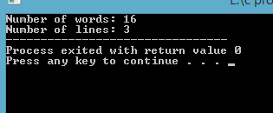

**RESULT:**

Thus the program implementation using files has been executed and tested successfully.

5 42

#### 6

**AIM :**

To write a C program to perform operations on singly, doubly and circular linked lists.

**ALGORITHMS :**

1. **SINGLY LINKED LIST**

###### CREATION

Step 1 : START

Step 2 : Include all the header files which are used in the program. Step 3 : Declare all the user defined functions.

Step 4 : Define a Node structure with two members data and next Step 5 : Define a Node pointer 'head' and set it to NULL.

Step 6 : Implement the main method by displaying the operations menu and make suitable function calls in the main method to perform user selected operations.

###### INSERTION

**Inserting At Beginning of the list**

Step 1 : Create a newNode with a given value.

Step 2 : Check whether list is Empty (head == NULL)

Step 3 : If it is Empty then, set newNode→next = NULL and head = newNode. Step 4 : If it is Not Empty then, set newNode→next = head and head = newNode.

###### Inserting At End of the list

Step 1 - Create a newNode with given value and newNode → next as NULL. Step 2 - Check whether the list is Empty (head == NULL).

## 43

Step 3 - If it is Empty then, set head = newNode.

Step 4 : If it is Not Empty then, define a node pointer temp and initialize with head.

Step 5 : Keep moving the temp to its next node until it reaches the last node in the list (until temp → next is equal to NULL).

Step 6 : Set temp → next = newNode.

###### Inserting At Specific location in the list (After a Node)

Step 1 : Create a newNode with a given value.

Step 2 : Check whether list is Empty (head == NULL)

Step 3 : If it is Empty then, set newNode → next = NULL and head = newNode. Step 4 : If it is Not Empty then, define a node pointer temp and initialize with head.

Step 5 : Keep moving the temp to its next node until it reaches the node after which we want to insert the newNode.

Step 6 : Every time check whether temp is reached to the last node or not. If it is reached to the last node then displays 'Given node is not found in the list!!!' and terminate the function.

Otherwise move the temp to the next node.

Step 7 : Finally, Set 'newNode → next = temp → next' and 'temp → next = newNode'

###### DELETION

**Deleting from Beginning of the list**

Step 1 : Check whether list is Empty (head == NULL)

Step 2 : If it is Empty then, display 'List is Empty!!! Deletion is not possible' and terminates the function.

Step 3 : If it is Not Empty then, define a Node pointer 'temp' and initialize with head. Step 4 : Check whether list is having only one node (temp → next == NULL)

Step 5 : If it is TRUE then set head = NULL and delete temp.

Step 6 : If it is FALSE then set head = temp → next, and delete temp.

###### Deleting from End of the list

Step 1 : Check whether list is Empty (head == NULL)

Step 2 : If it is Empty then, display 'List is Empty!!! Deletion is not possible' and terminates the function.

Step 3 : If it is Not Empty then, define two Node pointers 'temp1' and 'temp2' and initialize 'temp1' with head.

Step 4 : Check whether list has only one Node (temp1 → next == NULL)

Step 5 : If it is TRUE. Then, set head = NULL and delete temp1. And terminate the function.

Step 6 : If it is FALSE. Then, set 'temp2 = temp1 ' and move temp1 to its next node. Repeat the same until it reaches the last node in the list.

Step 7 : Finally, Set temp2 → next = NULL and delete temp1.

###### Deleting a Specific Node from the list

Step 1 : Check whether list is Empty (head == NULL)

Step 2 : If it is Empty then, display 'List is Empty!!! Deletion is not possible' and terminates the function.

Step 3 : If it is Not Empty then, define two Node pointers 'temp1' and 'temp2' and initialize 'temp1' with head.

Step 4 : Keep moving the temp1 until it reaches the exact node to be deleted or to the last node. And every time set 'temp2 = temp1' before moving the 'temp1' to its next node.

Step 5 : If it is reached to the last node then display 'Given node not found in the list!'. And terminate the function.

Step 6 : If it is reached to the exact node which we want to delete, then check whether list is having only one node or not

Step 7 : If the list has only one node and that is the node to be deleted, then set head = NULL and delete temp1 (free(temp1)).

Step 8 : If the list contains multiple nodes, then check whether temp1 is the first node in the list.

Step 9 : If temp1 is the first node then move the head to the next node (head = head → next) and delete temp1.

Step 10 : If temp1 is not first node then check whether it is last node in the list.

Step 11 : If temp1 is the last node then set temp2 → next = NULL and delete temp1.

Step 12 : If temp1 is not the first node and not the last node then set temp2 → next = temp1 → next and delete temp1 (free(temp1)).

###### SEARCH

Step 1 : Initialise the Current pointer with the beginning of the List.

Step 2 : Compare the KEY value with the Current node value; if they match then quit there else go to step-3.

Step 3 : Move the Current pointer to point to the next node in the list and go to step-2, till the list is not over or else quit.

###### DISPLAY

Step 1 : Check whether list is Empty (head == NULL)

Step 2 : If it is Empty then, display 'List is Empty!!!' and terminate the function. Step 3 : If it is Not Empty then, define a Node pointer 'temp' and initialize with head.

Step 4 : Keep displaying temp → data with an arrow (--->) until temp reaches to the last node Step 5 : Finally display temp → data with an arrow pointing to NULL (temp → data ---> NULL).

###### DOUBLY LINKED LIST

1. **CREATION**

Step 1 - Include all the header files which are used in the program. Step 2 - Declare all the user defined functions.

Step 3 - Define a Node structure with two members data and next Step 4 - Define a Node pointer 'head' and set it to NULL.

Step 5 - Implement the main method by displaying the operations menu and make suitable function calls in the main method to perform user selected operations.

###### INSERTION

**Inserting At Beginning of the list**

Step 1 - Create a newNode with given value and newNode → previous as NULL. Step 2 - Check whether list is Empty (head == NULL)

Step 3 - If it is Empty then, assign NULL to newNode → next and newNode to head.

Step 4 - If it is not Empty then, assign head to newNode → next and newNode to head.

###### Inserting At End of the list

Step 1 - Create a newNode with given value and newNode → next as NULL. Step 2 - Check whether list is Empty (head == NULL)

Step 3 - If it is Empty, then assign NULL to newNode → previous and newNode to head. Step 4 - If it is not Empty, then, define a node pointer temp and initialize with head.

Step 5 - Keep moving the temp to its next node until it reaches the last node in the list (until temp → next is equal to NULL).

Step 6 - Assign newNode to temp → next and temp to newNode → previous.

###### Inserting At Specific location in the list (After a Node)

Step 1 - Create a newNode with a given value.

Step 2 - Check whether list is Empty (head == NULL)

Step 3 - If it is Empty then, assign NULL to both newNode → previous & newNode → next and set newNode to head.

Step 4 - If it is not Empty then, define two node pointers temp1 & temp2 and initialize temp1 with head.

Step 5 - Keep moving the temp1 to its next node until it reaches the node after which we want to insert the newNode.

Step 6 - Every time check whether temp1 is reached to the last node. If it is reached to the last node then display 'Given node is not found in the list!!! Insertion is not possible!!!' and

terminate the function. Otherwise move the temp1 to the next node.

Step 7 - Assign temp1 → next to temp2, newNode to temp1 → next, temp1 to newNode → previous, temp2 to newNode → next and newNode to temp2 → previous.

###### DELETION

**Deleting from Beginning of the list**

Step 1 - Check whether list is Empty (head == NULL)

Step 2 - If it is Empty then, display 'List is Empty!!! Deletion is not possible' and terminates the function.

Step 3 - If it is not Empty then, define a Node pointer 'temp' and initialize with head.

Step 4 - Check whether list is having only one node (temp → previous is equal to temp → next) Step 5 - If it is TRUE, then set head to NULL and delete temp (Setting Empty list conditions)

Step 6 - If it is FALSE, then assign temp → next to head, NULL to head → previous and delete temp.

###### Deleting from End of the list

Step 1 - Check whether list is Empty (head == NULL)

Step 2 - If it is Empty, then display 'List is Empty!!! Deletion is not possible' and terminates the function.

Step 3 - If it is not Empty then, define a Node pointer 'temp' and initialize with head.

Step 4 - Check whether list has only one Node (temp → previous and temp → next both are NULL) Step 5 - If it is TRUE, then assign NULL to head and delete temp. And terminate from the function.

Step 6 - If it is FALSE, then keep moving temp until it reaches the last node in the list. (until temp → next is equal to NULL)

Step 7 - Assign NULL to temp → previous → next and delete temp.

###### Deleting a Specific Node from the list

Step 1 - Check whether list is Empty (head == NULL)

Step 2 - If it is Empty then, display 'List is Empty!!! Deletion is not possible' and terminate the function.

Step 3 - If it is not Empty, then define a Node pointer 'temp' and initialize with head.

Step 4 - Keep moving the temp until it reaches the exact node to be deleted or to the last node.

Step 5 - If it is reached to the last node, then display 'Given node not found in the list! Deletion not possible!!!' and terminate the function.

Step 6 - If it is reached to the exact node which we want to delete, then check whether list is having only one node or not

Step 7 - If list has only one node and that is the node which is to be deleted then set head to NULL and delete temp (free(temp)).

Step 8 - If list contains multiple nodes, then check whether temp is the first node in the list (temp == head).

Step 9 - If temp is the first node, then move the head to the next node (head = head → next), set head of previous to NULL (head → previous = NULL) and delete temp.

Step 10 - If temp is not the first node, then check whether it is the last node in the list. Step 11 - If temp is the last node then set temp of previous or next to NULL.

Step 12 - If temp is not the first node and not the last node, then set temp of previous of next to temp of next , temp of next of previous to temp of previous.

###### Displaying a Double Linked List

Step 1 - Check whether list is Empty (head == NULL)

Step 2 - If it is Empty, then display 'List is Empty!!!' and terminate the function. Step 3 - If it is not Empty, then define a Node pointer 'temp' and initialize with head. Step 4 - Display 'NULL <--- '.

Step 5 - Keep displaying temp → data with an arrow (<===>) until temp reaches to the last node Step 6 - Finally, display temp → data with an arrow pointing to NULL (temp → data ---> NULL).

###### CIRCULAR LINKED LIST

1. **CREATION**

Step 1 - Include all the header files which are used in the program. Step 2 - Declare all the user defined functions.

Step 3 - Define a Node structure with two members data and next Step 4 - Define a Node pointer 'head' and set it to NULL.

Step 5 - Implement the main method by displaying the operations menu and make suitable function calls in the main method to perform user selected operation.

###### INSERTION

**Inserting At Beginning of the list**

Step 1 - Create a newNode with a given value.

Step 2 - Check whether list is Empty (head == NULL)

Step 3 - If it is Empty then, set head = newNode and newNode→next = head .

Step 4 - If it is Not Empty then, define a Node pointer 'temp' and initialize with 'head'. Step 5 - Keep moving the 'temp' to its next node until it reaches the last node.

Step 6 - Set 'newNode → next =head', 'head = newNode' and 'temp → next = head'.

###### Inserting At End of the list

Step 1 - Create a newNode with a given value.

Step 2 - Check whether the list is Empty (head == NULL).

Step 3 - If it is Empty then, set head = newNode and newNode → next = head. Step 4 - If it is Not Empty then, define a node pointer temp and initialize with head.

Step 5 - Keep moving the temp to its next node until it reaches the last node in the list (until temp → next == head).

Step 6 - Set temp → next = newNode and newNode → next = head.

###### Inserting At Specific location in the list (After a Node)

Step 1 - Create a newNode with a given value.

Step 2 - Check whether list is Empty (head == NULL)

Step 3 - If it is Empty then, set head = newNode and newNode → next = head. Step 4 - If it is Not Empty then, define a node pointer temp and initialize with head.

Step 5 - Keep moving the temp to its next node until it reaches to the node after which we want to insert the newNode.

Step 6 - Every time check whether temp is reached to the last node or not. If it is reached to last node then display 'Given node is not found in the list!!!’ and terminate the function. Otherwise

move the temp to the next node.

Step 7 - If temp is reached to the exact node after which we want to insert the newNode then check whether it is last node (temp → next == head).

Step 8 - If temp is last node then set temp → next = newNode and newNode → next = head. Step 9 - If temp is not last node then set newNode → next = temp → next and temp → next =

newNode.

###### DELETION

**Deleting from Beginning of the list**

Step 1 - Check whether list is Empty (head == NULL)

Step 2 - If it is Empty then, display 'List is Empty!!! Deletion is not possible' and terminate the function.

Step 3 - If it is Not Empty then, define two Node pointers 'temp1' and 'temp2' and initialize both 'temp1' and 'temp2' with head.

Step 4 - Check whether list is having only one node (temp1 → next == head)

Step 5 - If it is TRUE then set head = NULL and delete temp1 (Setting Empty list conditions)

Step 6 - If it is FALSE move the temp1 until it reaches to the last node. (until temp1 → next == head

)

Step 7 - Then set head = temp2 → next, temp1 → next = head and delete temp2.

###### Deleting from End of the list

Step 1 - Check whether list is Empty (head == NULL)

Step 2 - If it is Empty then, display 'List is Empty!!! Deletion is not possible' and terminate the function.

Step 3 - If it is Not Empty then, define two Node pointers 'temp1' and 'temp2' and initialize 'temp1' with head.

Step 4 - Check whether list has only one Node (temp1 → next == head)

Step 5 - If it is TRUE. Then, set head = NULL and delete temp1. And terminate from the function.

Step 6 - If it is FALSE. Then, set 'temp2 = temp1 ' and move temp1 to its next node. Repeat the same until temp1 reaches to the last node in the list. (until temp1 → next == head)

Step 7 - Set temp2 → next = head and delete temp1.

###### Deleting a Specific Node from the list

Step 1 - Check whether list is Empty (head == NULL)

Step 2 - If it is Empty then, display 'List is Empty!!! Deletion is not possible' and terminate the function.

Step 3 - If it is Not Empty then, define two Node pointers 'temp1' and 'temp2' and initialize 'temp1'

with head.

Step 4 - Keep moving the temp1 until it reaches to the exact node to be deleted or to the last node. And every time set 'temp2 = temp1' before moving the 'temp1' to its next node.

Step 5 - If it is reached to the last node then display 'Given node not found in the list!'. And terminate the function.

Step 6 - If it is reached to the exact node which we want to delete, then check whether list is having only one node (temp1 → next == head)

Step 7 - If list has only one node and that is the node to be deleted then set head = NULL and delete temp1 (free(temp1)).

Step 8 - If list contains multiple nodes then check whether temp1 is the first node in the list (temp1

== head).

Step 9 - If temp1 is the first node then set temp2 = head and keep moving temp2 to its next node until temp2 reaches the last node. Then set head = head→next, temp2 → next = head and delete temp1.

Step 10 - If temp1 is not first node then check whether it is last node in the list.

Step 11- If temp1 is last node then set temp2 → next = head and delete temp1 (free(temp1)).

Step 12 - If temp1 is not first node and not last node then set temp2 → next = temp1 → next and delete temp1 (free(temp1)).

###### Displaying a circular Linked List

Step 1 - Check whether list is Empty (head == NULL)

Step 2 - If it is Empty, then display 'List is Empty!!!' and terminate the function.

Step 3 - If it is Not Empty then, define a Node pointer 'temp' and initialize with head.

Step 4 - Keep displaying temp → data with an arrow (--->) until temp reaches to the last node Step 5 - Finally display temp → data with arrow pointing to head → data

**PROGRAMS :**

1. **SINGLY LINKED LIST**

#include<stdio.h> #include<stdlib.h>

struct Node

{

int data;

struct Node *next

};

int main()

{

int choice,n,nodeaft,deletel, count;

struct Node *head=NULL,*temp,*neww,*temp2,*prev; do

{

printf("\n1.creation 2.Display 3.Insert@first 4.Ins@last 5.Ins@mid 6.Del@first 7.Del@mid 8.Del'@last 9.Search");

scanf("%d",&choice); switch(choice)

{

case 1:

printf("ENter the number other than 0"); scanf("%d",&n);

while(n!=0)

{

neww=(struct Node *)malloc(sizeof(struct Node)); neww->data=n;

neww->next=NULL; if(head==NULL)

{

head=neww; temp=head;

}

else

{

temp->next = neww; temp = neww;

}

printf("ENter the number other than 0"); scanf("%d",&n);

}

break; case 2:

temp=head; while(temp!=NULL)

{

printf("%d",temp->data); temp=temp->next;

}

printf("NULL"); break;

case 3:

printf("ENter the new value"); scanf("%d",&n);

neww=(struct Node *)malloc(sizeof(struct Node)); neww->data=n;

neww->next = head; head = neww;

break; case 4:

printf("ENter the new value"); scanf("%d",&n);

neww=(struct Node *)malloc(sizeof(struct Node)); neww->data=n;

neww->next=NULL; temp = head;

while(temp->next!=NULL) temp = temp->next;

temp->next=neww;

break; case 5:

printf("ENter the new value"); scanf("%d",&n);

printf("Enter the node after:"); scanf("%d",&nodeaft);

neww=(struct Node *)malloc(sizeof(struct Node)); neww->data=n;

temp = head; while(temp!=NULL)

{

if(temp->data==nodeaft) break;

temp = temp->next;

}

neww->next= temp->next;; temp->next = neww;

break; case 6:

temp = head;

head = temp->next; free(temp);

break; case 7:

temp = head;

printf("Enter the node to delete :"); scanf("%d",&n);

while(temp->data != n)

{

neww = temp; temp = temp->next;

}

neww->next = temp->next;

break; case 8:

temp = head;

while(temp->next != NULL)

{

neww = temp; temp = temp->next;

}

neww->next = NULL; free(temp);

break; case 9:

temp = head;

printf("Enter the element to search :"); scanf("%d",&n);

count =1;

while(temp != NULL)

{

if(temp->data == n)

{

printf("The ele %d is found %d position",temp->data,count); break;

}

temp = temp->next; count += 1

}

if(temp==NULL) printf("Not found");

break;

}

}while(choice<=8);

return 0;

}

**OUTPUT :**

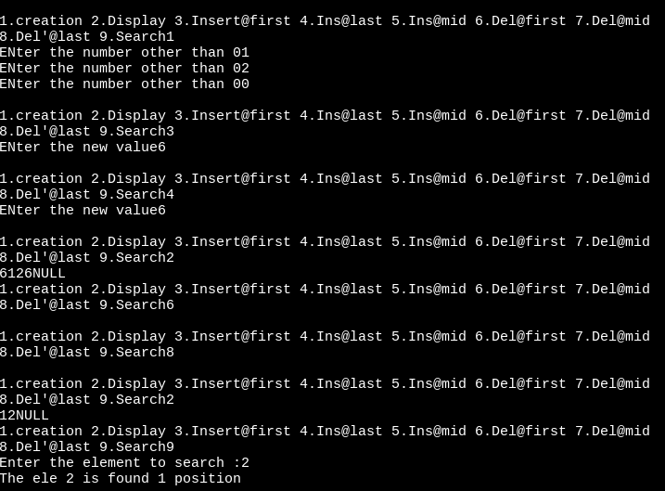

1. **DOUBLY LINKED LIST**

#include<stdio.h> #include<stdlib.h> struct Node

{

int data;

struct Node *next; struct Node *prev;

};

int main()

{

int choice,n,nodeaft,nodedel;

struct Node*head=NULL,*neww,*temp,*temp2,*temp3; do

{

printf("Enter ur choice 1.Create2.Display 3.Ins@first 4.Ins@last [5.Ins@mid6.Del@first7.Del@last8.Del@mid");](mailto:5.Ins@mid6.Del@first7.Del@last8.Del@mid)

scanf("%d",&choice); switch(choice)

{

case 1:

printf("Enter the number(other than 0): "); scanf("%d",&n);

while(n!=0){

neww=(struct Node*)malloc(sizeof(struct Node)); neww->data=n;

neww->next=NULL; neww->prev=NULL; if(head==NULL)

{

head=neww; temp = head;

}

else

{

temp->next=neww; neww->prev=temp; temp = neww;

}

printf("Enter the number(other than 0): "); scanf("%d",&n);

}

break; case 2:

temp=head; while(temp!=NULL)

{

printf("%d->",temp->data); temp = temp->next;

}

printf("NULL"); break;

case 3:

printf("Enter the number(other than 0): "); scanf("%d",&n);

neww=(struct Node*)malloc(sizeof(struct Node)); neww->data=n;

neww->next=NULL; neww->prev=NULL; temp = head;

neww->next=head; head->prev=neww; head = neww; break;

case 4:

printf("Enter the number(other than 0): "); scanf("%d",&n);

neww=(struct Node*)malloc(sizeof(struct Node)); neww->data=n;

neww->next=NULL; neww->prev=NULL;

temp=head;

while(temp->next!=NULL) temp=temp->next;

temp->next = neww; neww->prev = temp; break;

case 5:

printf("Enter the number(other than 0): "); scanf("%d",&n);

printf("Enter the nodeaft element:"); scanf("%d",&nodeaft);

neww=(struct Node*)malloc(sizeof(struct Node)); neww->data=n;

neww->next=NULL; neww->prev=NULL; temp=head;

while(temp->next!=NULL)

{

if(temp->data==nodeaft)break; temp=temp->next;

}

temp2 = temp->next; temp->next = neww; neww->prev = temp; neww->next = temp2; temp2->prev=neww; break;

case 6:

temp = head; head= head->next;

head->prev=NULL; free(temp);

break;

case 7:

temp=head;

while(temp->next!=NULL) temp=temp->next;

temp2=temp->prev; temp2->next=NULL; free(temp);

break; case 8:

printf("Enter the node to be deleted:"); scanf("%d",&nodedel);

temp=head;

while(temp->next!=NULL)

{

if(temp->data==nodedel) break;

temp=temp->next;

}

temp2=temp->prev; temp3=temp->next; temp2->next=temp3; temp3->prev=temp2; free(temp);

break;

}

}while(choice<=9); return 0;

}

**OUTPUT :**

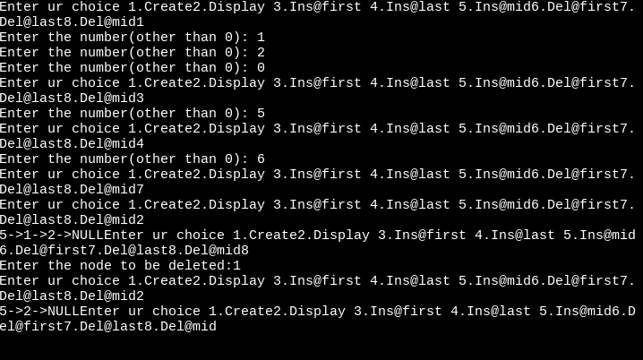

1. **CIRCULAR LINKED LIST**

#include<stdio.h> #include<stdlib.h> struct Node

{

int data;

struct Node *next;

};

int main()

{

int choice,n,nodeaft,noddel;

struct Node *head=NULL,*neww,*temp, *temp1; do

{

printf("1.Creation2.Display3.Ins@first 4.Ins@last 5.Ins@mid 6.Del@first 7.Del@mid 8Del@last");

scanf("%d",&choice); switch(choice)

{

case 1:

printf("Enter the number(other than 0):"); scanf("%d",&n);

while(n!=0)

{

neww=(struct Node*)malloc(sizeof(struct Node)); neww->data=n;

if(head==NULL)

{

head = neww; neww->next = head; temp=head;

}

else

{

temp->next = neww; neww->next=head; temp = neww;

}

printf("Enter the number(other than 0):"); scanf("%d",&n);

}

break; case 2:

temp = head;

while(temp->next!=head)

{

printf("%d->",temp->data); temp=temp->next;

}

printf("%d",temp->data); break;

case 3:

printf("Enter the number:"); scanf("%d",&n);

neww=(struct Node*)malloc(sizeof(struct Node)); neww->data=n;

temp = head;

while(temp->next!=head) temp = temp->next;

neww->next=head; head = neww; temp->next = head; break;

case 4:

printf("Enter the number:"); scanf("%d",&n);

neww=(struct Node*)malloc(sizeof(struct Node)); neww->data=n;

temp = head;

while(temp->next!=head) temp = temp->next;

temp->next= neww; neww->next= head; break;

case 5:

printf("Enter the number:"); scanf("%d",&n); printf("Enter the nodeafter:"); scanf("%d",&nodeaft);

neww=(struct Node*)malloc(sizeof(struct Node)); neww->data=n;

temp = head;

while(temp->next!=head){ if(temp->data==nodeaft) break;

temp = temp->next;

}

neww->next = temp->next; temp->next = neww;

break; case 6:

temp = head;

temp1 = head;

while(temp->next!=head){ temp = temp->next;

}

head = temp1->next; temp->next=head; free(temp);

break; case 7:

temp = head;

printf("Enter the node to delete:"); scanf("%d",&noddel); while(temp->data != noddel){

temp1 = temp; temp = temp->next;

}

temp1 ->next = temp ->next; free(temp);

case 8:

temp = head;

while(temp->next != head) { temp1 = temp;

temp = temp->next;

}

temp1->next = head; free(temp);

}

}while(choice<=8);

}

**OUTPUT :**

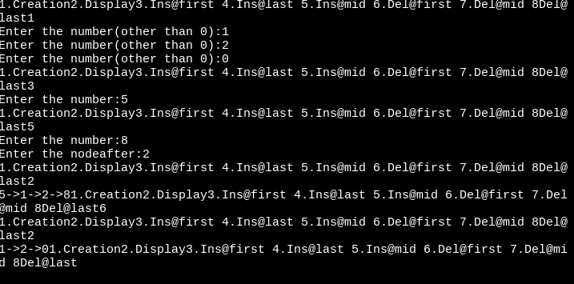

**RESULT :**

Thus, the C program to implement the operations of singly, doubly and circular linked list has been executed and tested successfully.

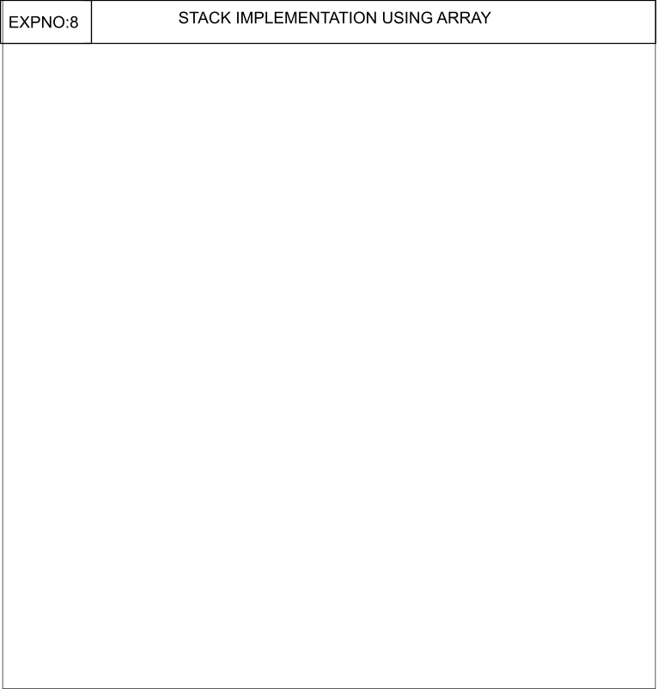**7**

###### AIM:

To write a C program to perform stack implementation using array

**ALGORITHMS**

1. **PUSH() OPEARTION**

Step 1: Start

Step 2: Declare Stack[MAX]; //Maximum size of Stack

Step 3: Check if the stack is full or not by comparing top with (MAX-1)

If the stack is full, Then print "Stack Overflow" i.e, stack is full and cannot be pushed with another element

Step 4: Else, the stack is not full

Increment top by 1 and Set, a[top] = x

which pushes the element x into the address pointed by top.

// The element x is stored in a[top] Step 5: Stop

###### POP()

Step 1: Start

Step 2: Declare Stack[MAX]

Step 3: Push the elements into the stack

Step 4: Check if the stack is empty or not by comparing top with base of array i.e 0 If top is less than 0, then stack is empty, print "Stack Underflow"

Step 5: Else, If top is greater than zero the stack is not empty, then store the value pointed by top in a variable x=a[top] and decrement top by 1. The popped element is x

Step:Stop

###### DISPLAY()

Step 1:START

Step 2 - Check whether stack is EMPTY. (top == -1)

Step 3 - If it is EMPTY, then display "Stack is EMPTY!!!" and terminate the function.

Step 4 - If it is NOT EMPTY, then define a variable 'i' and initialize with top. Display stack[i] value and decrement i value by one (i--).

Step 5 - Repeat above step until i value becomes '0'.

Step 6:STOP

###### PROGRAMS 1.POP() OPERATION:

#include <stdio.h>

int stack[100],i,j,choice=0,n,top=-1; void push();

void pop(); void show(); void main ()

{

printf("Enter the number of elements in the stack ");

scanf("%d",&n);

while(choice != 4)

{

printf("Chose one from the below options...\n");

printf("\n1.Push\n2.Pop\n3.Show\n4.Exit")

;

printf("\n Enter your choice \n"); scanf("%d",&choice); switch(choice)

{

case 1:

{

push(); break;

}

case 2:

{

pop(); break;

}

case 3:

{

show(); break;

}

case 4:

{

printf("Exiting. ");

break;

}

default:

{

");

}

}

printf("Please Enter valid choice

}

};

void push ()

{

int val;

if (top == n ) printf("\n Overflow"); else

{

printf("Enter the value?"); scanf("%d",&val);

top = top +1; stack[top] = val;

}

}

void pop ()

{

if(top == -1) printf("Underflow"); else

top = top -1;

}

void show()

{

for (i=top;i>=0;i--)

{

printf("%d\n",stack[i]);

}

if(top == -1)

{

printf("Stack is empty");

}

}

###### OUTPUT:

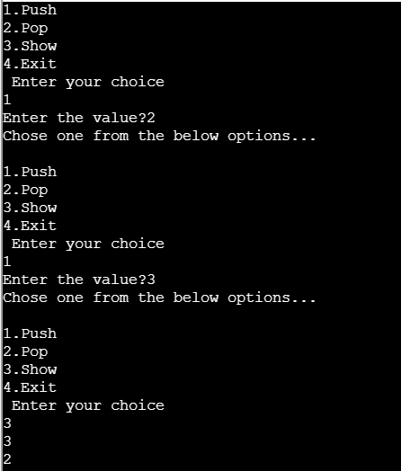

**RESULT:**

Thus the program implementation using stack using array has been executed and tested successfully.

###### EX.NO : 8

**AIM :**

To write a C program to implement stack using linked list.

**ALGORITHMS :**

1. **PUSH ( ) OPERATION**

Step 1 : START

Step 2 : Create a node new and declare variable top Step 3 : Set new data part to be Null

// The first node is created, having null value and top pointing to it Step 4 : Read the node to be inserted.

Step 5 : Check if the node is Null, then print "Insufficient Memory"

Step 6 : If node is not Null, assign the item to data part of new and assign top to link part of new and also point stack head to new.

Step 7 : STOP

###### POP ( ) OPERATION

Step 1 : START

Step 2 : Check if the top is NULL, then print “Stack Underflow”.

Step 3 : If top is not NULL, assign top’s link part to temp and assign temp to stack_head’s link part.

Step 4 : STOP

###### DISPLAY ( ) OPERATION

Step 1 : START

Step 2 : Check if the top is NULL, then print “Stack is Empty”. Step 3 : If it is not NULL, assign temp pointer to top.

Step 4 : Display temp →data and move it to the next node. Repeat the same until temp reaches to the first node in the stack (temp→next != NULL).

Step 5 : STOP

**PROGRAM :**

#include<stdio.h> #include<stdlib.h> struct Node

{

int data;

struct Node *next;

};

int main()

{

int choice,ele;

struct Node *Top=NULL,*neww,*temp; do

{

printf("Enter ur option1.Push 2.Pop 3.DIsplay\n"); scanf("%d",&choice);

switch(choice)

{

case 1:

printf("Enter the data to push:"); scanf("%d",&ele); //10

neww=(struct Node*)malloc(sizeof(struct Node)); neww->data=ele;

neww->next=NULL; if(Top==NULL)

{

Top = neww; temp = Top;

}

else

{

neww->next = Top;

Top = neww;

}

break; case 2:

if(Top==NULL) printf("Stack is underflow"); else

{

temp = Top;

Top= Top->next;

}

break; case 3:

if(Top==NULL)

{

printf("Stack is Empty");

}

else{ temp=Top;

while(temp!=NULL){ printf("\n%d",temp->data); temp = temp->next;

}

}

break;

}

}while(choice<=3); return 0;

}

**OUTPUT :**

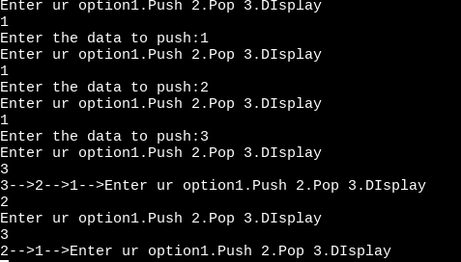

**RESULT :**

Thus, the program to implement stack operations using linked list has been executed and tested successfully.

|  |  |
| --- | --- |
| **EX.NO:9** | **STACK APPLICATIONS** |
| **AIM:**  To write a C program to perform stack applications.  **ALGORITHMS**   1. **CONVERSION OF INFIX TO POSTFIX EXPRESSION**   Step 1: START  Step 2: DECLARE stack, top, push, pop, priority, exp, *e, x Step 3: DECLARE stack[100], top=-1  Step 4: DECLARE VOID function push with argument x and perform stack[++top] = x; Step 5: DECLARE CHAR function pop with no argument and perform IF(top -1) - return -1; or ELSE - return stack[top--];  Step 6: DECLARE INT function priority with argument x and perform IF(x == '(') - return 0; IF(x '+' || x == '-') - RETURN 1; IF(x == '*' || x == '/') - RETURN 2; or ELSE return 0;  Step 7: In main function GET the value of the expression and store it in variable exp Step 8: Assign e=exp;  Step 9: WHILE(*e != '\0') - IF(isa1num(*e)) - PRINT("%c ",*e); ELSE IF(*e == '(') - push(*e);  ELSE IF(*e == ')') - WHILE((x = pop()) != '(') - PRINT("%c ", x); ELSE —  WHILE(priority(stack[top])>= priority(*e)) - PRINT ("%c ",pop()); push(*e); e++; WHILE(top != -1) PRINT (”%c ",pop());  Step 10: ENDWHILE  Step 11: RETURN 0;  Step 12: STOP   1. **POSTFIX EXPRESSION EVALUATION**   Step 1 : START  Step 2 : DECLARE stack, top, push, pop, priority, exp, *e, x, n1, n2, n3, num  Step 3 : DECLARE stack[20], top=-1  Step 4 : DECLARE VOID function push with argument x and perform stack[++top] = x; Step 5 : DECLARE INT function pop with no argument and perform RETURN stack[top--]; Step 6 : In main function GET the value of the expression and store it in variable exp  Step 7 : Assign e=exp;  Step 8 : WHILE(*e != '\0') - IF(ISDIGIT(*e) - num = *e - 48;-push(num);-else-n1 = pop();-n2 = pop();SWITCH(*e)-CASE '+': - n3 = n1 + n2;- BREAK; - CASE '-'. n3 = n2 - n1; BREAK ;CASE '*':- n3 = n1 * n2; BREAK; CASE '/': n3 = n2 / n1; BREAK; push(n3); e++;  Step 9 : ENDWHILE  Step 10 : PRINT The result of expression %s %d\n\n",exp,pop()); Step 11 : RETURN 0 | |

Step 12 : STOP

###### PROGRAMS

1. **CONVERSION OF INFIX TO POSTFIX EXPRESSION**

#inc1ude<stdio.h> #include<ctype.h> char stack[100]; int top = -1;

void push(char x) stack[++top] = x;

char pop() if(top == -1)

return -1;

else

return stack[top--];

int priority(char x) if(x == '(')

return 0;

if(x == '+' || x == '-')

##### return 1;

if(x == '*' || x == '/')

##### return 2;

return 0;

int main()

char exp[100]; char *e, x;

printf("Enter the expression : "); scanf("%s",exp);

printf("\n"); e = exp;

while(*e != '\0')

if(isa1num(*e)) printf("%c ",*e);

else if(*e == '(') push(*e);

else if(*e == ')')

## 76

while((x = pop()) != '(')

printf("%c ", x); else

while(priority(stack[top]) >= priority(*e)) printf(”°%c ",pop());

push(*e);

e++;

while(top != -1)

printf("%c ",pop());

}return 0;

###### OUTPUT :

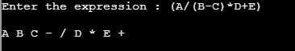

1. **POSTFIX EXPRESSION EVALUATION**

#include<stdio.h> int stack[20];

int top = -1; void push(int x)

stack[++top] = x;

int pop()

return stack[top--];

int main()

char exp[20]; char *e;

int n1,n2,n3,num;

printf("Enter the expression :: "); scanf("%s",exp);

e = exp; while(*e != '\0')

if(isdigit(*e))

## 77

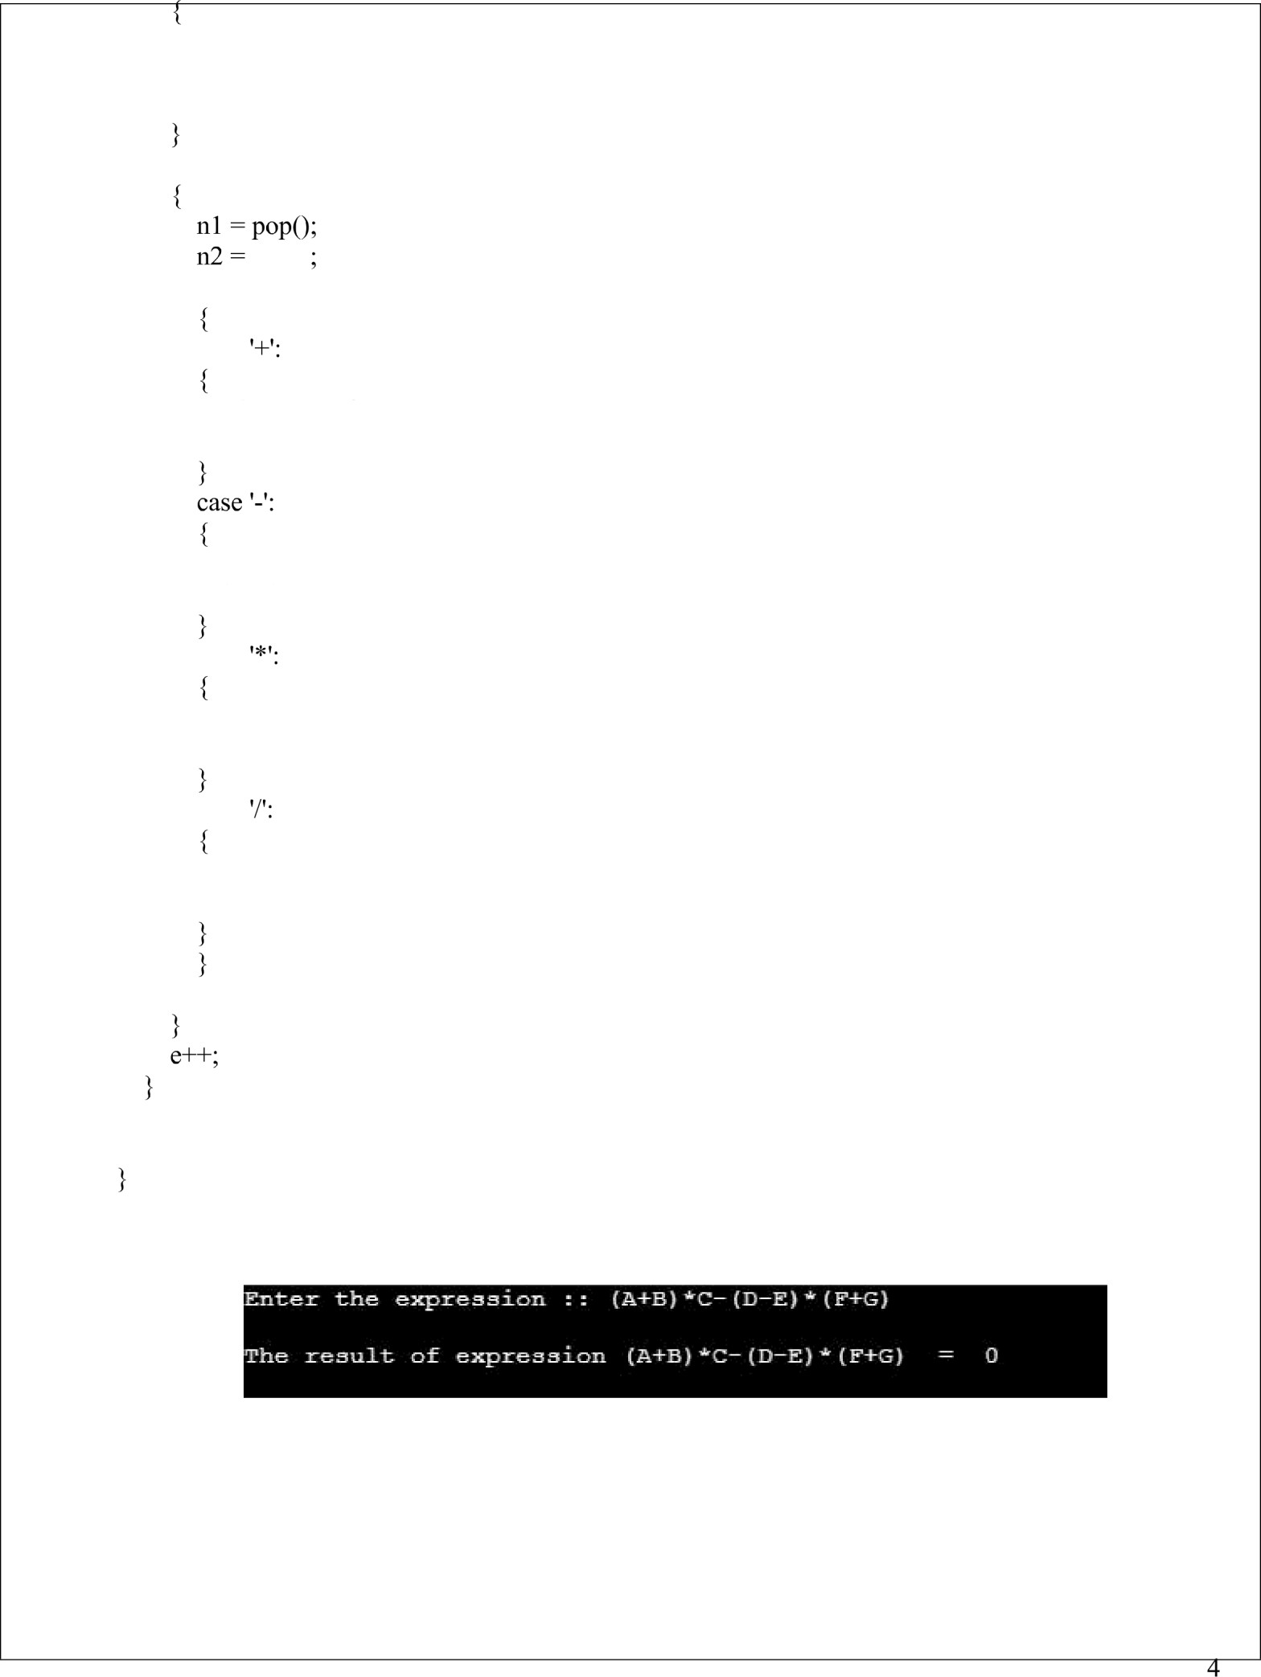num = *e - 48;

push(num);

else

pop()

switch(*e) case

n3 = n1 + n2; break;

n3 = n2 - nl; break;

case

n3 = n1 * n2; break;

case

n3 = n2 / nl; break;

push(n3);

printf("uiThe result of expression %s = %duiui",exp,pop()); return 0;

**OUTPUT :**

## 78

**RESULT:**

Thus the program implementation using stack applications has been executed and tested successfully.

## 79



80









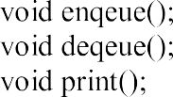

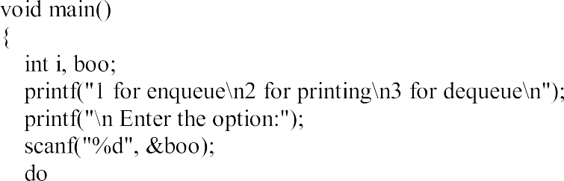

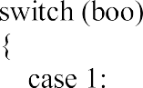

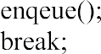





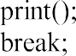



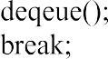

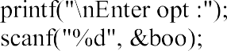

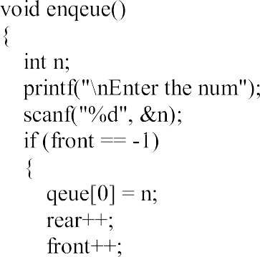

## 81



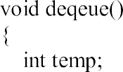



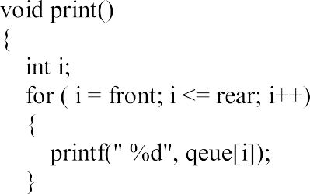

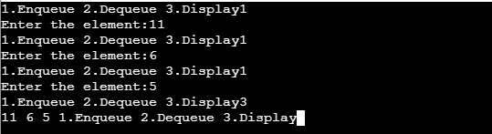

## 82

###### AIM:

To write a C program to perform queue using linked list

**ALGORITHMS**

1. **CREATION**

Step 1-START

Step 2 - Include all the header files which are used in the program. And declare all the user defined functions.

Step 3 - Define a 'Node' structure with two members data and next.

Step 4 - Define two Node pointers 'front' and 'rear' and set both to NULL.

Step 5 - Implement the main method by displaying Menu of list of operations and make suitable function calls in the main method to perform user selected operation.

Step 6-STOP

###### ENQUEUE()

Step 1-START

Step 1 - Create a newNode with given value and set 'newNode → next' to NULL.

Step 2 - Check whether queue is Empty (rear == NULL)

Step 3 - If it is Empty then, set front = newNode and rear = newNode.

Step 4 - If it is Not Empty then, set rear → next = newNode and rear = newNode. Step 5-STOP

###### DEQUEUE()

Step 1:START

Step 2 - Check whether queue is Empty (front == NULL).

Step 3 - If it is Empty, then display "Queue is Empty!!! Deletion is not possible!!!" and terminate from the function

Step 4 - If it is Not Empty then, define a Node pointer 'temp' and set it to 'front'. Step 5 - Then set 'front = front → next' and delete 'temp' (free(temp)).

Step 6-STOP

## 83

###### DISPLAY

Step 1:START

Step 2 - Check whether queue is Empty (front == NULL).

Step 3 - If it is Empty then, display 'Queue is Empty!!!' and terminate the function. Step 4 - If it is Not Empty then, define a Node pointer 'temp' and initialize with front.

Step 5- Display 'temp → data --->' and move it to the next node. Repeat the same until 'temp' reaches to 'rear' (temp → next != NULL).

Step 6 - Finally! Display 'temp → data ---> NULL'. Step 7:STOP

**PROGRAMS**

#include<stdio.h> struct Node

{

int data;

struct Node *next;

};

int main()

{

struct Node

*front=NULL,*rear=NULL,*neww,*temp; int choice,ele;

do

{

printf("\nEnter ur option 1.Enqueue 2.Dequeue 3.Display\n");

scanf("%d",&choice); switch(choice)

{

case 1:

neww=(struct

Node*)malloc(sizeof(struct Node));

printf("Enter the data:");

scanf("%d",&ele); neww->data=ele; neww->next=NULL; if(front==NULL)

{

front = neww; rear = front;

}

else

{

}

break; case 2:

rear->next=neww; rear = neww;

if(front==NULL) printf("Queue is empty");

else{ temp=front;

front = temp->next; free(temp);

}

break; case 3:

if(front==NULL) printf("Queue is empty");

else{temp=front; while(temp!=NULL)

{

}

}

break;

printf("%d->",temp->data); temp=temp->next;

}

}while(choice<=3); return 0;

}

###### OUTPUT:

**RESULT:**

Thus the C program to perform queue using linked list is implemented, executed and verified successfully

EX

|  |  |
| --- | --- |
| EX.NO:12 | PRIORITY QUEUE |
| **Aim:**  To create a program for priority Queue Implementation using linked list in ascending order and descending order.  **Algorithm:**   1. **Priority Queue Implementation using linked list in ascending order.**   Step 1: Create new node with DATA and PRIORITY  Step 2: Check if HEAD has lower priority. If true follow Steps 3-4 and end. Else goto Step 5. Step 3: NEW -> NEXT = HEAD  Step 4: HEAD = NEW  Step 5: Set TEMP to head of the list  Step 6: While TEMP -> NEXT != NULL and TEMP -> NEXT -> PRIORITY > PRIORITY Step 7: TEMP = TEMP -> NEXT  [END OF LOOP]  Step 8: NEW -> NEXT = TEMP -> NEXT Step 9: TEMP -> NEXT = NEW  Step 10: End   1. **Priority Queue Implementation using linked list in descending order.**   Step 1: Create new node with DATA and PRIORITY  Step 2: Check if HEAD has lower priority. If true follow Steps 3-4 and end. Else goto Step 5. Step 3: NEW -> NEXT = HEAD  Step 4: HEAD = NEW  Step 5: Set TEMP to head of the list  Step 6: While TEMP -> NEXT != NULL and TEMP -> NEXT -> PRIORITY > PRIORITY Step 7: TEMP = TEMP -> NEXT  [END OF LOOP]  Step 8: NEW -> NEXT = TEMP -> NEXT Step 9: TEMP -> NEXT = NEW  Step 10: End | |

87

**Program:**

1. **Priority Queue Implementation using linked list in ascending order.**

#include<stdio.h> #define MAX 10 struct P_Queue

{

int data;

int priority;

};

int main()

{

struct P_Queue p[MAX];

int choice,prior,ele,i,rear=-1; do

{

printf("Option 1.Insertion 2.Deletion 3.Display"); scanf("%d",&choice);

switch(choice)

{

case 1:

printf("Enter the data:"); scanf("%d",&ele); printf("Enter the priority"); scanf("%d",&prior); if(rear==-1){

p[++rear].data=ele; p[rear].priority=prior;

## 88

}

else{

p[++rear].data=ele; p[rear].priority=prior;

}

Sort(p,rear);

break; case 2:

if(rear==-1)

printf("Queue is empty"); else

{

for(i=0;i<=rear;i++){ p[i].data = p[i+1].data;

p[i].priority=p[i+1].priority;

}

rear--;

}

break; case 3:

for(i=rear;i>=0;i--)

{

printf("%d %d",p[i].data,p[i].priority); printf("\n");

}

break;

}

}while(choice<=3);

## 89

return 0;

}

void Sort(struct P_Queue p[],int rear)

{

int i,j;

for(i=0;i<=rear;i++)

{

for(j=i+1;j<=rear;j++)

{

if(p[i].priority<p[j].priority){ int data=p[i].data;

int prior=p[i].priority; p[i].data=p[j].data; p[i].priority=p[j].priority; p[j].data=data; p[j].priority=prior;

}

}

}

}

**OUTPUT:**

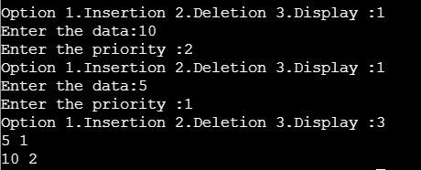

90

# Priority Queue Implementation using linked list in descending order.

#include <stdio.h> #include <stdlib.h> struct node

{

int data;

struct node* left, *right;

};

void printCurrentLevel(struct node* root, int level); int height(struct node* node);

struct node* newNode(int data);

void printLevelOrder(struct node* root)

{

int h = height(root); int i;

for (i=1; i<=h; i++) printCurrentLevel(root, i);

}

void printCurrentLevel(struct node* root, int level)

{

if (root == NULL) return;

if (level == 1)

printf("%d ", root->data); else if (level > 1)

{

printCurrentLevel(root->left, level-1); printCurrentLevel(root->right, level-1);

}

## 91

}

int height(struct node* node)

{

if (node==NULL) return 0;

else

{

int lheight = height(node->left); int rheight = height(node->right); if (lheight > rheight)

return(lheight+1); else return(rheight+1);

}

}

struct node* newNode(int data)

{

struct node* node = (struct node*)

malloc(sizeof(struct node)); node->data = data;

node->left = NULL; node->right = NULL;

return(node);

}

int main()

{

struct node *root = newNode(1);

## 92

**OUTPUT:**

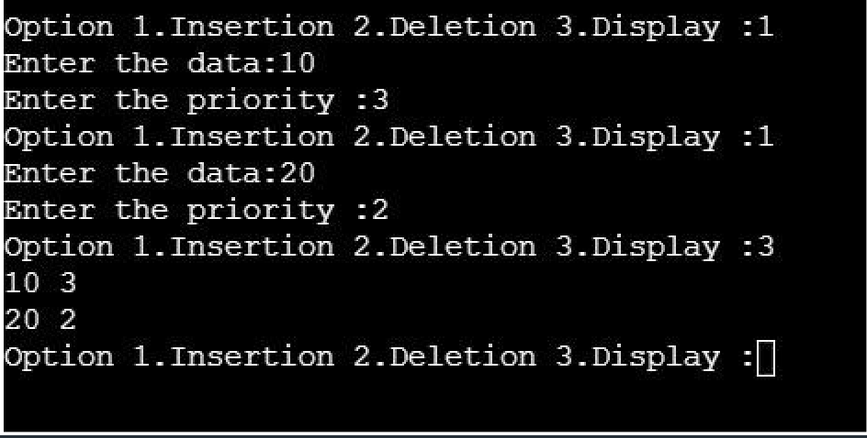

**RESULT:**

Thus the program implementation using priority queue has been executed and tested successfully.

## 93

|  |  |
| --- | --- |
| EX.NO: 13 | **QUEUE APPLICATION** |
| **AIM:**  To level order traversal of a binary tree using queue.  **ALGORITHMS:**  Step 1 : Create an empty queue q  Step 2 : temp_node = root /start from root/ Step 3 : Loop while temp_node is not NULL Step 4 : print temp_node->data.  Step 5 : Enqueue temp_node’s children (first left then right children) to q Step 6 : Dequeue a node from q and assign it’s value to temp_node  **PROGRAM:**  **Level order Traversal of a Binary Tree using Queue**  #include <stdio.h> #include <stdlib.h>  /* A binary tree node has data, pointer to left child  and a pointer to right child */ struct node  {  int data;  struct node* left, *right;  };  /* Function protoypes */  void printCurrentLevel(struct node* root, int level); int height(struct node* node);  struct node* newNode(int data);  /* Function to print level order traversal a tree*/ | |

94

void printLevelOrder(struct node* root)

{

int h = height(root); int i;

for (i=1; i<=h; i++) printCurrentLevel(root, i);

}

/* Print nodes at a current level */

void printCurrentLevel(struct node* root, int level)

{

if (root == NULL) return;

if (level == 1)

printf("%d ", root->data); else if (level > 1)

{

printCurrentLevel(root->left, level-1); printCurrentLevel(root->right, level-1);

}

}

/* Compute the "height" of a tree -- the number of nodes along the longest path from the root node down to the farthest leaf node.*/

int height(struct node* node)

{

if (node==NULL) return 0;

else

## 95

{

/* compute the height of each subtree */ int lheight = height(node->left);

int rheight = height(node->right);

/* use the larger one */ if (lheight > rheight)

return(lheight+1); else return(rheight+1);

}

}

/* Helper function that allocates a new node with the given data and NULL left and right pointers. */

struct node* newNode(int data)

{

struct node* node = (struct node*)

malloc(sizeof(struct node)); node->data = data;

node->left = NULL; node->right = NULL;

return(node);

}

/* Driver program to test above functions*/ int main()

{

struct node *root = newNode(1); root->left = newNode(2);

## 96

root->right = newNode(3); root->left->left = newNode(4); root->left->right = newNode(5);

printf("Level Order traversal of binary tree is \n"); printLevelOrder(root);

return 0;

}

**OUTPUT:**

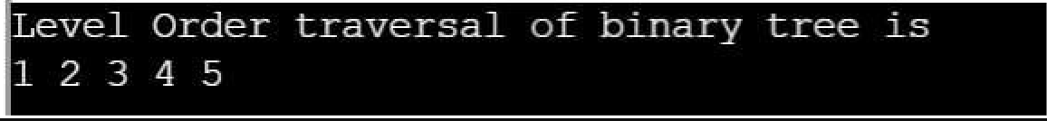

**RESULT:**

Thus the level order traversal of a Binary Tree using Queue.

## 97

|  |  |
| --- | --- |
| **EX.NO:14** | **BINARY SEARCH TREE** |
| **AIM :**  TowriteaCprogramtoimplement Binary Search Tree Operations.  **ALGORITHMS :**  **1. TO INSERT A NODE**  Step 1: Create a new BST node and assign values to it. Step 2:insert(node, key)   1. If root == NULL,   return the new node to the calling function.   1. if root=>data < key   call the insert function with root=>right and assign the return value in root=>right. root->right = insert(root=>right,key)   1. if root=>data > key   call the insert function with root->left and assign the return value in root=>left. root=>left = insert(root=>left,key)  Step 3: Finally, return the original root pointer to the calling function.   1. **DISPLAY USING PRE-ORDER**   Step 1:Visit or print the root. Step 2:Traverse the left subtree.  Step 3:Traverse the right subtree.   1. **SEARCH IN BINARY TREE**   Step 1: Start from the root.  Step 2: Compare the searching element with root, if less than root, then recurse for left, else recurse for right.  Step 3:If the element to search is found anywhere, return true, else return false. | |

98

* 1. **FIND MINIMUM IN SEARCH TREE**

Step 1:Traverse the node from root to left recursively until left is NULL.

Step 2:The node whose left is NULL is the node with minimum value.

* 1. **FIND MAXIMUM IN SEARCH TREE**

### Step 1:Traverse the node from root to right recursively until right is NULL.

Step 2:The node whose right is NULL is the node with maximum value.

**PROGRAMS :**

#include <stdio.h> #include <stdlib.h>

struct node { int key;

struct node *left, *right;

};

struct node* newNode(int item)

{

struct node* temp

= (struct node*)malloc(sizeof(struct node)); temp->key = item;

temp->left = temp->right = NULL; return temp;

}

void inorder(struct node* root)

{

if (root != NULL) { inorder(root->left); printf("%d \n", root->key); inorder(root->right);

}

}

struct node* insert(struct node* node, int key)

{

if (node == NULL) return newNode(key);

if (key < node->key)

## 99

node->left = insert(node->left, key); else if (key > node->key)

node->right = insert(node->right, key);

return node;

}

int main()

{

struct node* root = NULL; root = insert(root, 27);

insert(root, 14);

insert(root, 19);

insert(root, 10);

insert(root, 35);

insert(root, 31);

insert(root, 42);

inorder(root);

return 0;

}

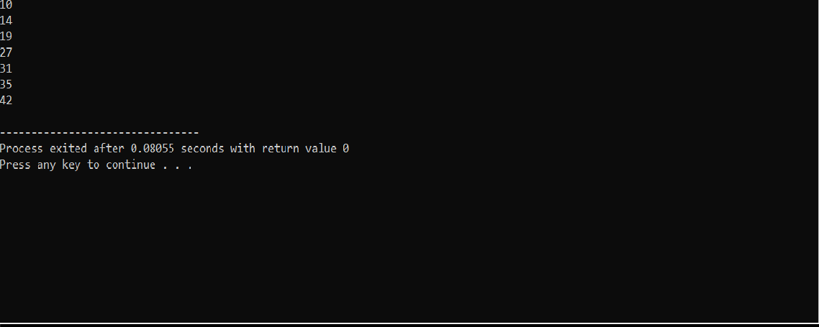**OUTPUT:**

**RESULT:**

Thus, the program to implement Binary Search Tree has beenexecutedand tested

successfully.

## 100

**SEPARATE CHAINING**

|  |  |
| --- | --- |
| **Ex.No: 15** | **HASHING TECHNIQUES** |
| **AIM:**  To write aC program to implement separate chaining in hashing.  **ALGORITHMS :**   1. **Algorithm to insert a value in hash table using separate chaining collision resolutiontechnique**   Hashtable is an array of pointers. All pointers are initialized to NULL ( head[ TABLE_SIZE] = NULL)  Step1: Read the value to be inserted  step 2: create a new node using malloc function  step 3: Assign the value read to the data field of newnode (newnode -> data =value) step 4: compute the index index = value % TABLE_SIZE  step 5: if head[ index] is NULL then  step 5.1: attach the newnode as first node  step 6: else  step 6.1 : attach the newnode as lastnode   1. Algorithm to insert a value in linear probing   Hashtable is an array of size = TABLE_SIZE Step 1: Read the value to be inserted, key Step 2: let i = 0  Step 3: hkey = key% **TABLE_SIZE**  Step 4 :compute the index at which the key has to be inserted in hash table  **index = (hkey + i) % TABLE_SIZE**  Step 5: if there is no element at that index then insert the value at index and STOP Step 6: If there is already an element at that index  step 4.1: i = i+1  step 7: if i< TABLE_SIZE then go to step 4  **PROGRAMS :**  #include <stdio.h> #include <stdlib.h> #define TABLE_SIZE 10 struct node  {  int data;  struct node *next;  };  struct node *head[TABLE_SIZE]={NULL},*c; void insert()  {  int i,key;  printf("\nenter a value to insert into hash table\n"); scanf("%d",&key); | |

101

i=key%TABLE_SIZE;

struct node * newnode=(struct node *)malloc(sizeof(struct node)); newnode->data=key;

newnode->next = NULL; if(head[i] == NULL)

head[i] = newnode; else

{

c=head[i];

while(c->next != NULL)

{

c=c->next;

}

c->next=newnode;

}

}

void search()

{

int key,index;

printf("\nenter the element to be searched\n"); scanf("%d",&key);

index=key%TABLE_SIZE; if(head[index] == NULL)

printf("\n Search element not found\n"); else

{

for(c=head[index];c!=NULL;c=c->next)

{

if(c->data == key)

{

printf("search element found\n"); break;

}

}

if(c==NULL)

printf("\n Search element not found\n");

}

}

void display()

{

int i; for(i=0;i<TABLE_SIZE;i++)

{

printf("\nentries at index %d\n",i); if(head[i] == NULL)

{

printf("No Hash Entry");

}

else

{

}

}

for(c=head[i];c!=NULL;c=c->next) printf("%d->",c->data);

} 102

main()

{

int opt,key,i; while(1)

{

printf("\nPress 1. Insert\t 2. Display \t3. Search \t4.Exit \n"); scanf("%d",&opt);

switch(opt)

{

case 1:

insert(); break;

case 2:

display(); break;

case 3:

search(); break;

case 4:exit(0);

}

}

}

**OUTPUT:**

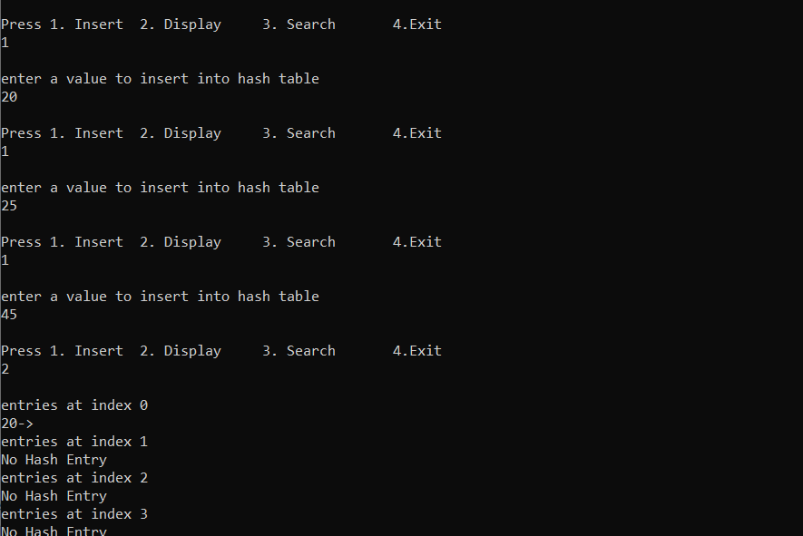

.

## 103

#include <stdio.h> #include<stdlib.h> #define TABLE_SIZE 10

int h[TABLE_SIZE]={NULL};

void insert()

{

int key,index,i,flag=0,hkey;

printf("\nenter a value to insert into hash table\n"); scanf("%d",&key);

hkey=key%TABLE_SIZE; for(i=0;i<TABLE_SIZE;i++)

{

index=(hkey+i)%TABLE_SIZE; if(h[index] == NULL)

{

h[index]=key; break;

}

}

if(i == TABLE_SIZE)

printf("\nelement cannot be inserted\n");

}

void search()

{

int key,index,i,flag=0,hkey; printf("\nenter search element\n"); scanf("%d",&key); hkey=key%TABLE_SIZE; for(i=0;i<TABLE_SIZE; i++)

{

index=(hkey+i)%TABLE_SIZE; if(h[index]==key)

{

printf("value is found at index %d",index); break;

}

}

if(i == TABLE_SIZE)

printf("\n value is not found\n");

}

void display()

{

int i;

printf("\nelements in the hash table are \n");

## 104

for(i=0;i< TABLE_SIZE; i++)

printf("\nat index %d \t value = %d",i,h[i]);

}

main()

{

int opt,i; while(1)

{

printf("\nPress 1. Insert\t 2. Display \t3. Search \t4.Exit \n"); scanf("%d",&opt);

switch(opt)

{

case 1:

insert(); break;

case 2:

display(); break;

case 3:

search(); break;

case 4:exit(0);

}

}

}

**OUTPUT:**

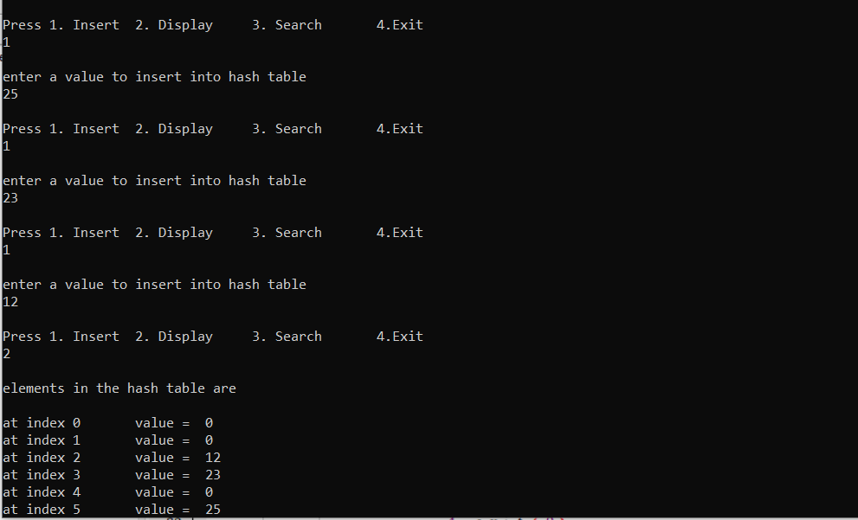

## 105

**RESULT:**

Thus,the Cprogram to implement linear probing collision avoidance technique Executed and the output was verified successfully.

## 106